- PracticeMode
A safe place to practise filling in online forms before doing it for real
Group number | I2-4
Chosen project | PracticeMode
Team members | Kashvi Prawal (Product Owner)  Rohan Aditya Ram  Atheer Alajmi  Perumal Marimuthu  Siddharth Jiyani
Course and section | CS-GY 6063 Software Engineering I, Section I2, Fall 2026
Instructor | Raz Saremi
Date | October 20, 2026
AI-use disclosure | The team used AI’s assistance (Claude and Chatgpt) to reorganise our draft user stories into the required template. A recording of our team meeting was transcribed automatically. The project idea, scope decisions, personas, and priorities are the team's own, and every story was read, edited, and agreed by its author and a reviewing teammate.

Abstract
PracticeMode is a web-based practice environment that lets learners rehearse filling in real online forms in a controlled space, without entering personal information on external websites. Practice forms are extracted from supported source websites, verified by a human Form Reviewer, and only then made available to Learners, who receive per-field hints, translated guidance, fictional preparation checklists, autosaved drafts, and validation feedback. Instructors respond to assistance requests and monitor learner progress. This document provides the architectural blueprint for the 16 MVP user stories defined in Sprint 1. It describes the three-tier client-server architecture (React, Django, PostgreSQL), the integrated domain model, the REST interface contracts, and the UML use case, sequence, state machine, and activity views, and it maps every MVP story and non-functional requirement to the components, interfaces, and diagrams that realize them, including server-side permission enforcement, bcrypt and HttpOnly-cookie security, the learner privacy boundary, and the Sprint 1 performance targets.

Table of Contents
The document is organised into the following tabs, in reading order.
- Cover, Abstract & Table of Contents (this tab)
- System Overview & Context
- UML Model Views: Requirements, Behavior & Structure
- Data Architecture: Integrated Domain Model
- Interface Contracts & Behavioral Dynamics: Sequence, State Machines & Activity Flows
- Design Decisions, Traceability Matrix, NFRs & Risks, and Why and Where We Use UML
- Sprint 1 Revisions
- Team Participation and Design Discussions
- Consistency and Validation
- Burndown Chart

2. Architecture Overview

2.1 System Overview
PracticeMode is a web-based application that provides learners with a platform to practice filling out forms online in a controlled environment that does not require providing personal information on external websites. PracticeMode supports three types of users: Learner, Instructor, and Form Reviewer.

PracticeMode is a system designed using a three-tier client-server architecture. These tiers include the Presentation tier, Application tier, and Data tier. The Application tier also employs a modular approach that separates routing, business logic, and data access functionalities.

The Presentation Layer offers role-specific interfaces. Learners are capable of searching for approved forms, practicing on the forms, getting guidance on a per-field basis, saving uncompleted attempts, and requesting instructors' help. Instructors are able to see authorized requests for assistance and progress of learners. Form Reviewers can import supported form structures, look at the extracted fields and approve or reject forms prior to their publication.

Application Layer receives requests from these interfaces, controls access based on user roles, implements the application's logic and coordination of data storage. The Data Layer stores forms' definitions, metadata of fields, review results, practice attempts, guidance and assistance.

The system has a controlled form-extraction functionality that extracts supported form structures from the source URL and creates practice-form definitions out of them. These forms should be reviewed and approved to become available for further practice attempts.

Also, the browser extension will be developed to extract the form structures supported by PracticeMode, which include fields, input type, and validation attributes from external websites. The data will then be transferred from the browser extension to the PracticeMode back end via a secure API. Validation and normalization of the data will be done on the back end before storing it in the PostgreSQL database with pending-approval status. After being approved by an authorized form reviewer, the form will be ready for use at PracticeMode.

2.1.1 System Context Diagram
Figure 2.0 provides a high-level view of PracticeMode's system boundary and its interactions with external actors and source websites. The system supports three primary user roles: Learner, Instructor, and Form Reviewer.
Learners interact with the platform to search for approved forms, complete practice attempts, access guidance, and request assistance. Instructors manage authorized assistance requests and monitor Learner progress. Form Reviewers import and verify extracted form structures before approving them for publication.
The browser extension retrieves supported form structures from external websites and transfers the extracted metadata to the PracticeMode backend for validation and review. All Learner practice activities remain within the PracticeMode platform, and practice answers are not submitted to external websites.
Figure 2.0: PracticeMode System Context Diagram
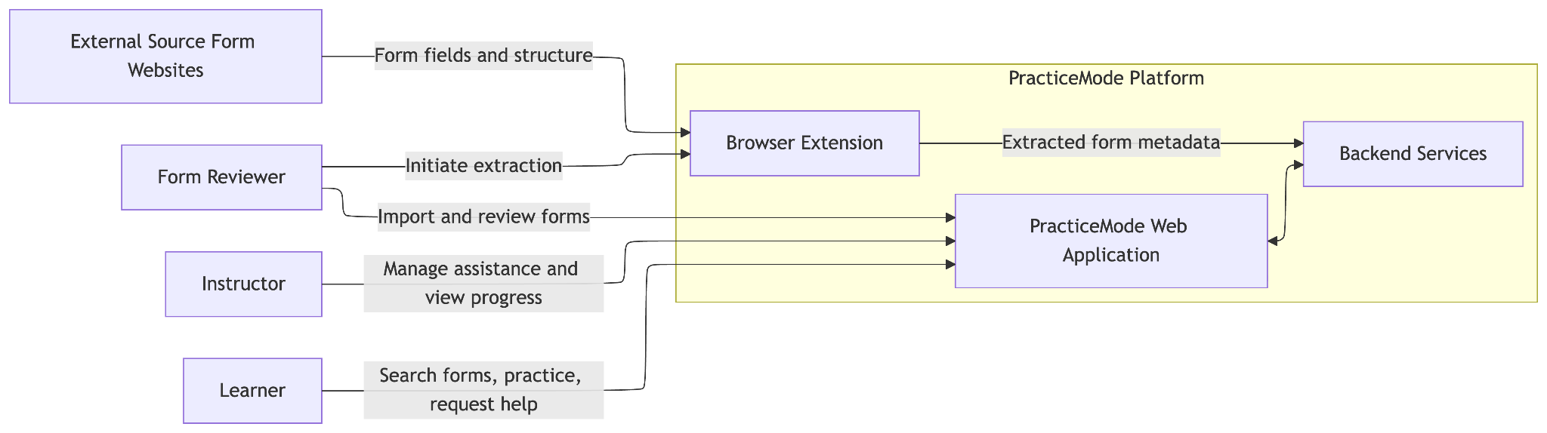

2.2 Architectural Style and Justification
Chosen architectural style: Three-tier Client-Server Architecture with a Layered Backend.

The architectural design separates responsibilities into the following tiers:

Presentation Layer (Client):

A React web application interface provides forms, instructions, dashboards, and reviewing interfaces. The web browser is used to connect the application server using HTTPS requests to REST API services. The frontend handles presentation and user interactions, while all security-sensitive authorization and resource ownership checks are enforced by the backend.

Application Layer (Server):

The Python-based Django server processes incoming requests, validates user access, and executes business logic. The backend is organized into modules responsible for authentication and authorization, form catalog management, form extraction and review, practice attempts, guidance, instructor assistance, and learner progress tracking. Django REST Framework (DRF) will provide REST API endpoints for communication with the React frontend and browser extension.

Data Layer (Database):

PostgreSQL holds the data for the application which includes role, form schema, field information, reviews, practice sessions, saved responses, help tickets, and practice activities. Database access is done via the backend and not through the browser.

Justification
A layered client-server architecture is suitable for PracticeMode for four main reasons.

- Separation of responsibilities: The client is responsible for user interface, the server takes care of the application logic, while the database manages persistent storage. This simplifies the maintenance and testing process.

- Security and privacy: Authentication, authorization, and ownership checks take place on the server side. The learners will only be using the practice versions, and their responses are not sent to the actual external websites. This is consistent with the permission and privacy policies of Sprint 1.

- Maintainability and collaboration: Separate application modules will enable team members to work on various features and have minimal overlapping changes to code. It will be possible for the team to develop the form extractor (browser extension), practice attempts, and instructor assistance without integrating their business logic in one module.

- Implementation feasibility: Use of one modular backend along with one relational database makes the solution more viable within the time frame of the course as compared to microservices that have to be deployed individually.

2.3 Main System Components and Responsibilities
The architecture identifies the following components with distinct responsibilities.

Component | Responsibility | Related MVP Stories
Role-Based Web Interface | Provides Learner, Instructor, and Form Reviewer screens and sends API requests | US-01, US-02, US-03, US-04, US-05
Authentication and Authorization Module | Validates access and enforces role and resource-ownership permissions | US-01
Form Catalog Module | Searches and filters published practice forms | US-02
Browser Extension | Extracts supported form structures from the active external website and sends them to the Django API | US-25
Form Review Module | Manages review queues, source references, notifications, and approval decisions | US-04, US-10, US-16, US-17
Practice Attempt Module | Renders supported form definitions, maintains drafts, restores answers, validates submissions, and records feedback | US-08, US-11, US-26
Guidance Module | Retrieves translated field guidance, contextual hints, and fictional preparation checklists | US-09, US-12, US-18
Instructor Assistance Module | Records assistance requests and provides authorized Instructor access to request details | US-03, US-05
Learner Progress Module | Retrieves authorized progress measures and applies Instructor filters | US-22
PostgreSQL Database | Persists application entities, relationships, and records needed by the above modules | All MVP stories requiring persistence

The application server owns the business logic for each component. Every protected operation passes through server-side authentication and authorization checks before accessing protected records.

The extraction component is distinct from the learner practice component. It communicates with supported source websites to obtain form definitions, while the practice component operates exclusively on approved copies stored in PracticeMode.

This separation prevents learners' entered practice answers from being transmitted to the source websites.

2.4 Component Communication

Figure 2.1 illustrates the main logical components and their communication boundaries.

HTTPS requests are made by the frontend to the REST API. The backend receives requests, performs authentication and authorization, routing requests to the relevant application modules and retrieving or updating the PostgreSQL record when required.

The browser extension extracts supported form structures from external webpages and sends the extracted metadata to the Django backend through an authenticated REST API. The Django import endpoint (API-15, owned by the Form Review Module) validates and normalizes the received data, creates a pending-review record in PostgreSQL, and makes it available to authorized Form Reviewers.

The Form Review Module permits the reviewer to check the source references and the extracted fields for the approval or rejection of the form. Upon the approval, the form will become searchable and accessible via the learner portal.

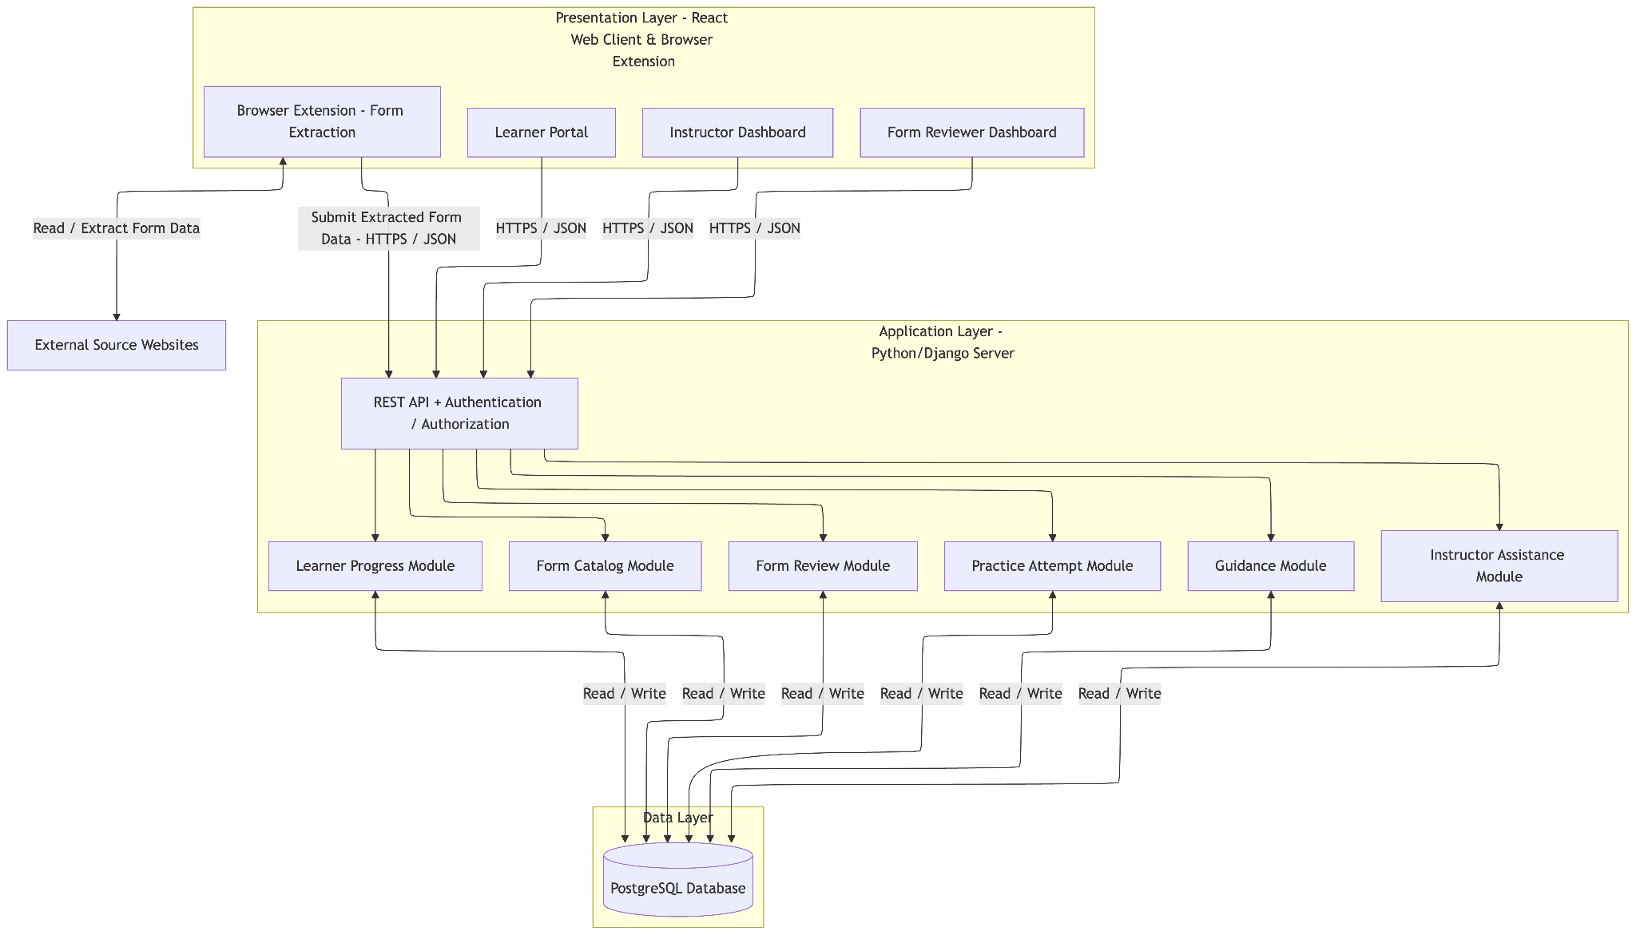
The learner practice operations employ the locally stored practice-form definitions and never send the learner answers to the external source.
Figure 2.1: PracticeMode Logical Component Architecture

2.5 Deployment Architecture
PracticeMode is designed to support reproducible local development and a production-style hosted environment without requiring a distributed microservices infrastructure.

Development Environment
During development, the React frontend will use Node.js and npm for dependency management and running the development server, while Python and Django will handle backend operations. PostgreSQL will provide persistent storage. These components will run locally on team members' machines, with communication through configured API endpoints.

Communication between frontend and backend will take place based on the local address of API. The backend will be connected to the local PostgreSQL database using environment configuration.

This approach lets the team develop components independently but in the architecture that is going to be deployed in production.

Hosted Environment
In the case of a hosted deployment, the frontend will be deployed via HTTPS while the application server will run as a single backend process. PostgreSQL will run as an independent database that is accessible only by the application server.

An application hosting service or even one virtual server can host the application, and the specific vendor can be decided later in the course of implementation without affecting the architecture.

The backend will store the database credentials and all sensitive information as environment variables on the server side.

External Dependencies
- Source websites: Read by the Browser Extension only, to obtain supported public form structure types; the Django server never contacts them.
- Node.js and npm: Used for React frontend development, dependency management, and building frontend assets.
- Python and Django: Used for server-side application logic, authentication, authorization, API development, and database operations.
- PostgreSQL: Provides relational data persistence.
- Browser Extension: Runs inside a supported web browser and extracts supported form structures from external webpages. It communicates with the Django backend through authenticated HTTPS API requests.
- Browser runtime: Runs the React web interface.

For the MVP, practice submission does not require an external form-submission API, AI model service, payment gateway, or third-party analytics platform.

Deployment and Communication Constraints
- Browser-to-server communication uses HTTPS in the hosted environment.
- The PostgreSQL database is not directly accessible from the public browser.
- Only server-side backend components can modify stored form review decisions and practice records.
- Access to Form Reviewer operations requires Form Reviewer permissions.
- Learner attempt access is restricted to the authorized Learner.
- Instructor access to learner progress and assistance records is restricted to authorized records.
- The platform supports a reproducible localhost deployment before any optional cloud deployment.

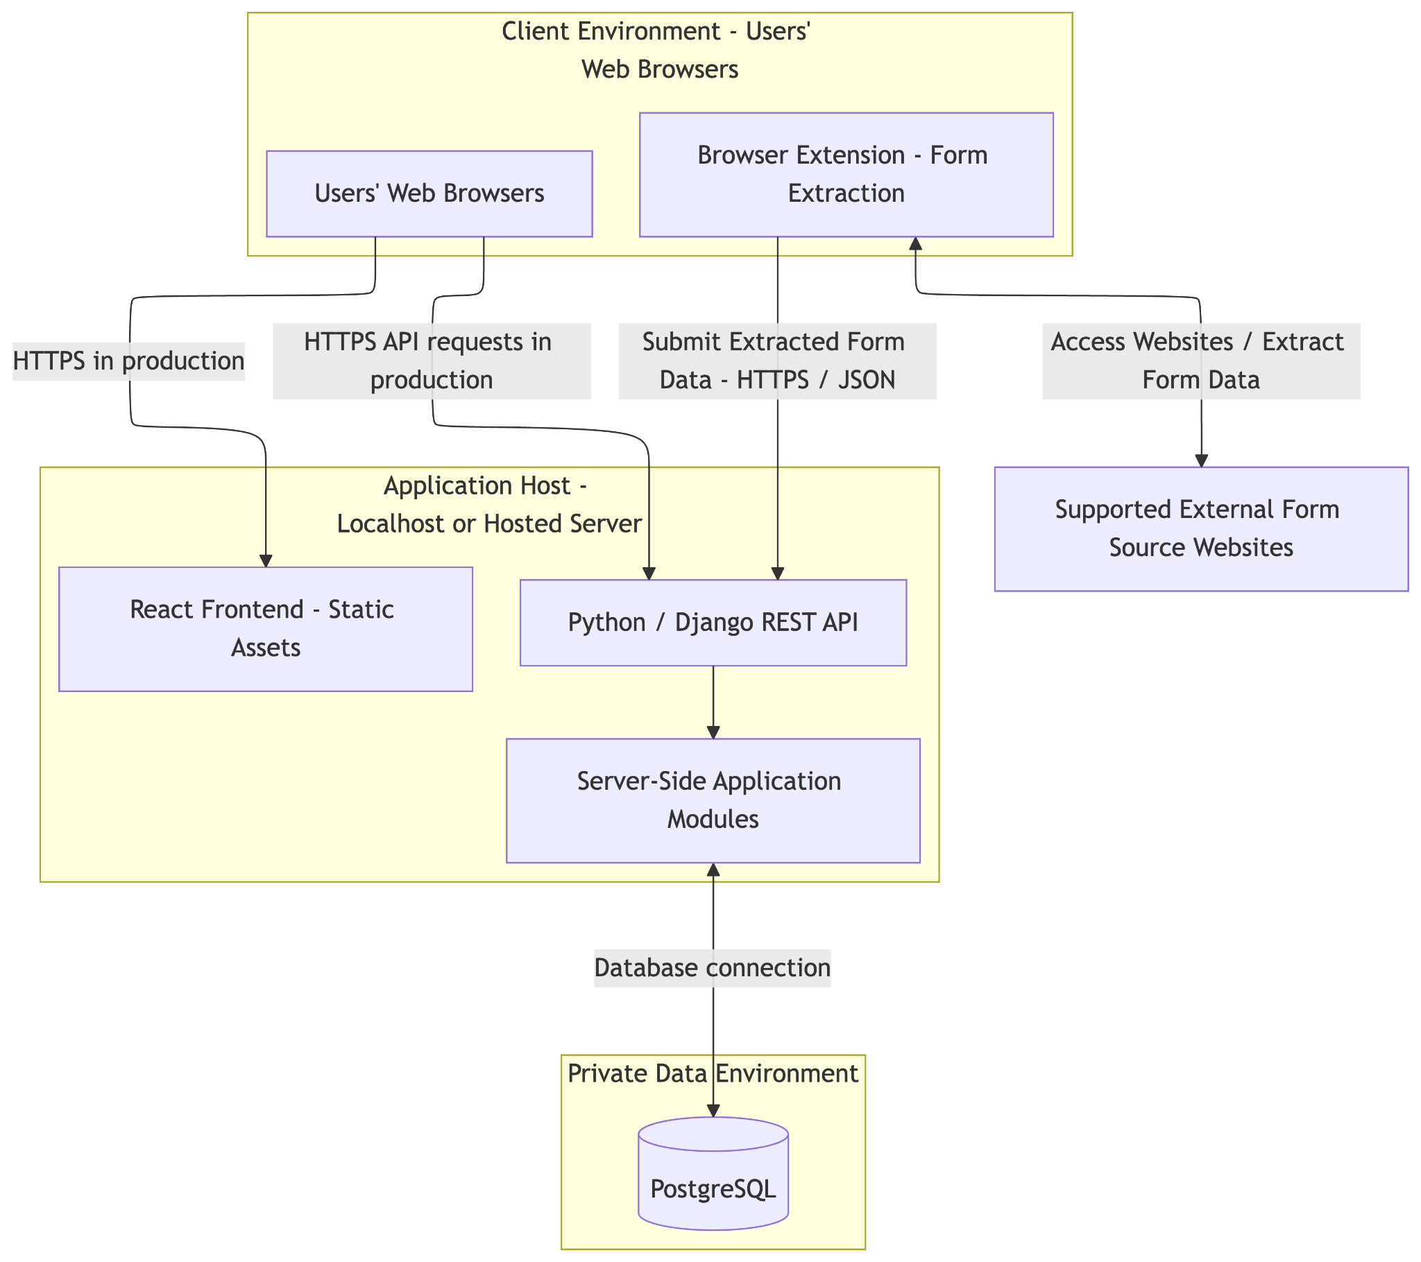

Figure 2.2: PracticeMode Physical Deployment View

2.6 Architecture Alignment with Non-Functional Requirements
The architecture directly addresses the four non-functional requirement areas defined in Sprint 1.

NFR | Architectural Mechanism
Permissions | Server-side role-based authorization and ownership checks on protected API operations
Security | All form metadata received from the browser extension shall be treated as untrusted input. The Django backend shall verify Form Reviewer permissions, validate supported field types and constraints, and reject invalid payloads before creating pending-review records. Staff passwords shall be hashed using bcrypt, authentication cookies shall be secured with HttpOnly, HTTPS shall be enforced, and uploaded files shall undergo server-side content, type, and size validation.
Privacy | Learner identity data limited to the agreed minimal information; practice answers remain inside PracticeMode and are never submitted to source websites
Performance | A single backend service, indexed relational queries, lightweight form definitions, and controlled extraction processing to support the Sprint 1 response-time targets

The corresponding test methods and measurable targets are retained from Sprint 1 and will be mapped in the Sprint 2 NFR traceability table.

2.7 Architectural Scope and Design Boundaries
Architecture concentrates on 16 MVP user stories defined for Sprint 1. The stretch user stories are not necessary to implement the main workflow for the learners’ practice.
These capabilities are not part of the MVP architectural requirements: creating a workshop via access code (US-06), playback of recorded sessions (US-07), alternative form layouts (US-20), and Private Instructor Notes (US-23).
The system is not intended to fill out the real-life forms automatically for learners or send the answers from practice to original websites.
This architecture allows the implementation of the whole workflow for learners’ practice starting with import and review of the supported form till its completion.

3. Modeling Choices and UML Model Views
This section states, for each common design view, whether PracticeMode uses UML, another notation, or an existing figure, and why. We used UML where the picture carries information that prose or a table would not, such as call order, permission checks, status rules, or multiplicities. We used a table where the detail is mostly fields, such as endpoint inputs, errors and roles. We did not redraw a view that another figure already shows, so the component and deployment views remain Figure 2.1 and Figure 2.2.

View | Choice | Figure(s) | Reason
Use case | UML | UC-01 to UC-04 | Each role reaches different behaviours under different permissions. UC-01 shows shared access, and UC-02 (Learner), UC-03 (Instructor) and UC-04 (Form Reviewer) each show one role’s path.
Class / domain model | UML class diagram | DM-01 | Most MVP stories depend on how PracticeForm, Field, Attempt and Answer relate, and a class diagram shows those multiplicities directly. A separate ER diagram would repeat it, because each class maps to one database table.
Sequence | UML | SQ-01, SQ-04 (here), SQ-02, SQ-03 (Section 6) | In these flows the order of calls decides whether a story is met. The permission check must fail before the Form Review Module runs (SQ-01), and a progress read must return only learners assigned to that instructor (SQ-04).
State machine | UML | STM-02, STM-03 (here), STM-01 (Section 6) | Attempt and AssistanceRequest have a status that changes what later calls may do. Answers lock once an attempt is COMPLETED, and a SCHEDULED request is visible only to its assigned instructor and learner.
Activity | UML | ACT-01 | Search is a decision path inside the Form Catalog Module (valid filters, matching forms or an empty result), not a conversation between modules, so an activity diagram fits it better than a sequence.
Component | Another Notation | Figure 2.1 | Figure 2.1 already shows the modules and their boundaries, so we did not redraw it.
Deployment | Another Notation | Figure 2.2 | Figure 2.2 already shows the browser, Django server, PostgreSQL and source site, so we did not redraw it.
Interfaces | API table | - | Each endpoint needs inputs, outputs, errors, allowed callers and story IDs, which a table shows more clearly than a UML interface diagram.
Package | Skipped | - | The backend is one Django process, and Figure 2.1 already shows its modules.

Coverage: Structural views: DM-01, Figure 2.1, Figure 2.2. Behavioural views: UC-01 to UC-04, SQ-01, SQ-04 (here), SQ-02, SQ-03 (Section 6), ACT-01, STM-02, STM-03 (here), STM-01 (Section 6).

Requirements View: Use Cases

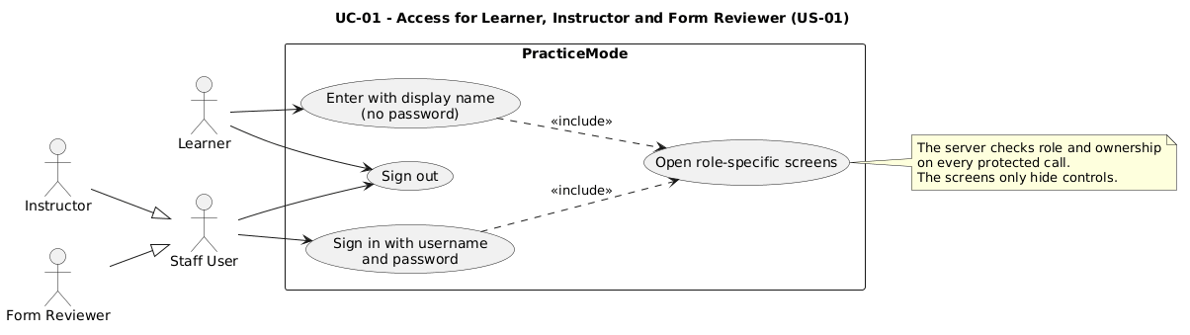

Figure UC-01 - Access for Learner, Instructor and Form Reviewer (US-01: display-name entry for learners, username and password for staff, role-specific screens)

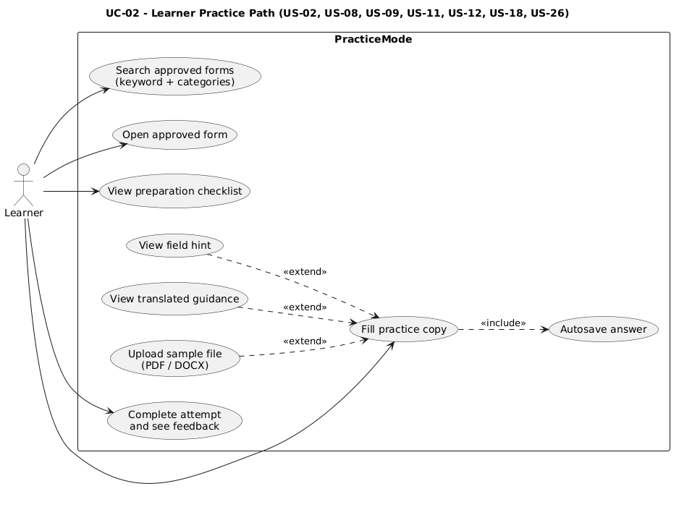
Figure UC-02 - Learner Practice Path (US-02, US-08, US-09, US-11, US-12, US-18, US-26: search, open an approved form, hints, translation, checklist, autosave and completion)
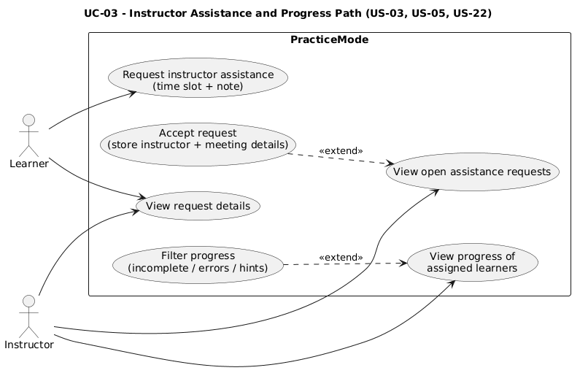
Figure UC-03 - Instructor Assistance and Progress Path (US-03, US-05, US-22: help requests, acceptance, and progress filters for assigned learners)
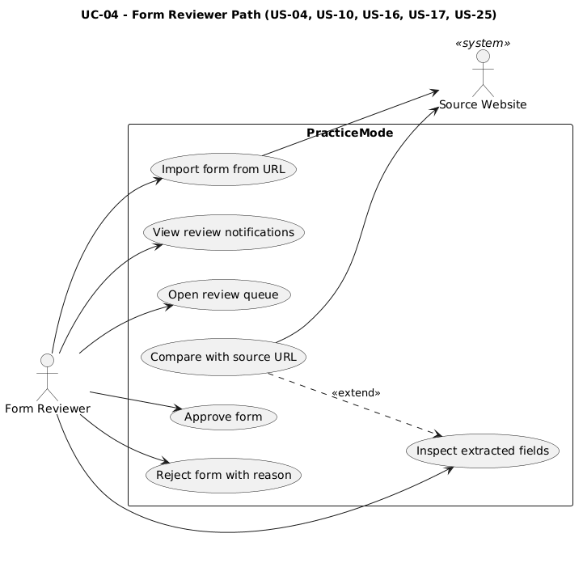
Figure UC-04 - Form Reviewer Path (US-04, US-10, US-16, US-17, US-25: import, notifications, review queue, source comparison, approve or reject)

Behavioral Dynamics: Sequence

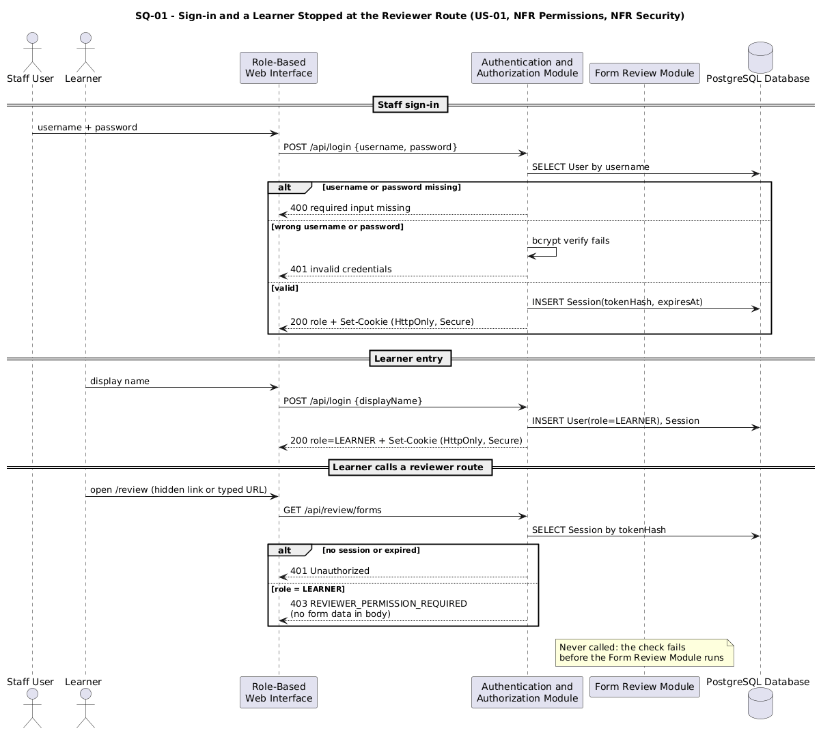

Figure SQ-01 - Sign-in and a Learner Stopped at the Reviewer Route (US-01, NFR Permissions, NFR Security: bcrypt check, HttpOnly cookie, and a 401/403 before the Form Review Module runs)

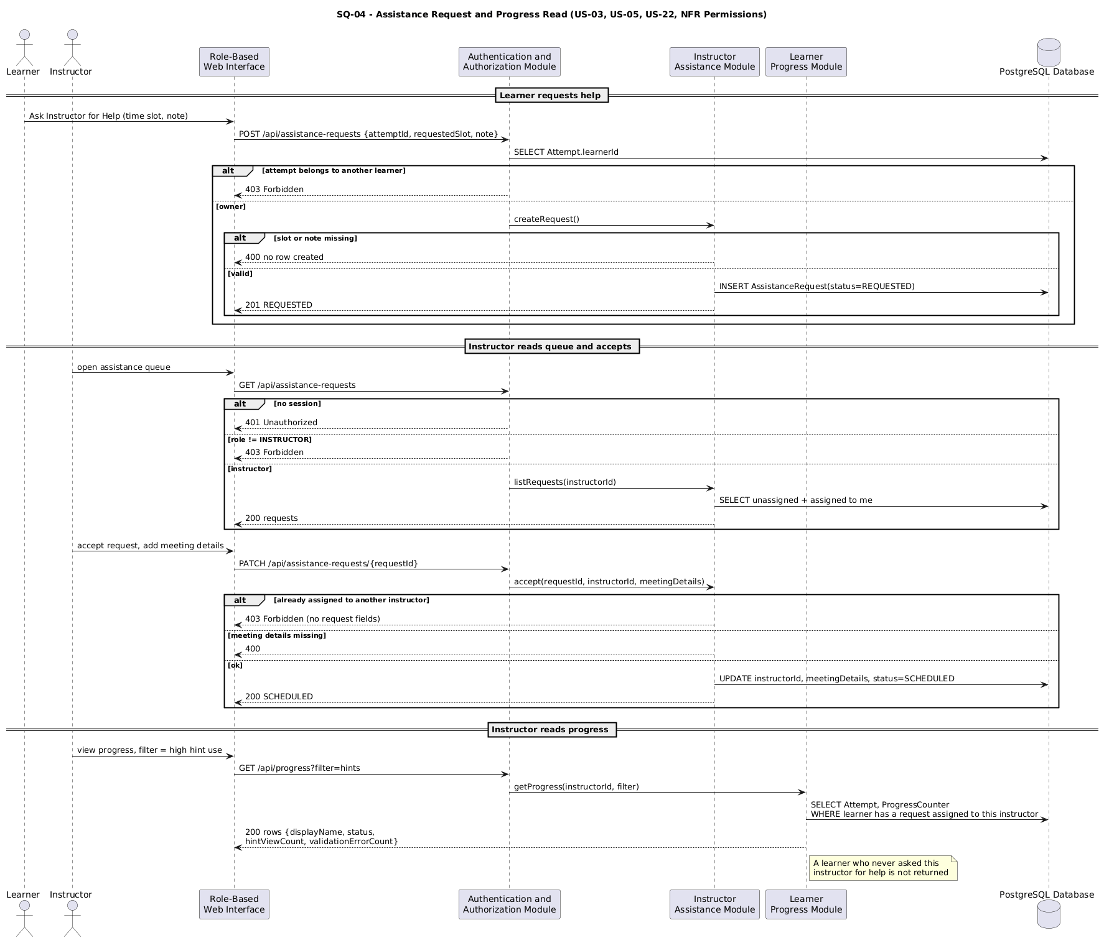

Figure SQ-04 - Assistance Request and Progress Read (US-03, US-05, US-22, NFR Permissions: attempt ownership, instructor role, acceptance, and progress limited to assigned learners)

Processing Logic: Activity
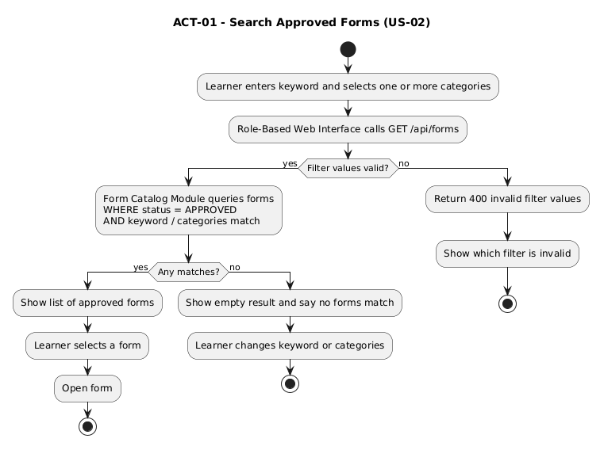

Figure ACT-01 - Search Approved Forms (US-02: valid filters, approved forms only, and an explicit empty result)

Lifecycle Management: State Machines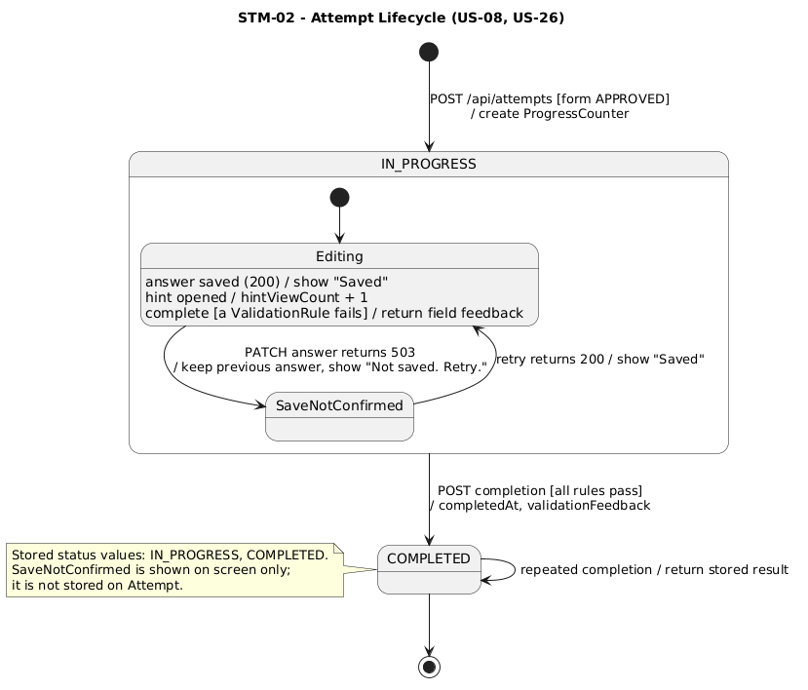

Figure STM-02 - Attempt Lifecycle (US-08, US-26: IN_PROGRESS with an unconfirmed-save path, then COMPLETED; repeated completion returns the stored result)

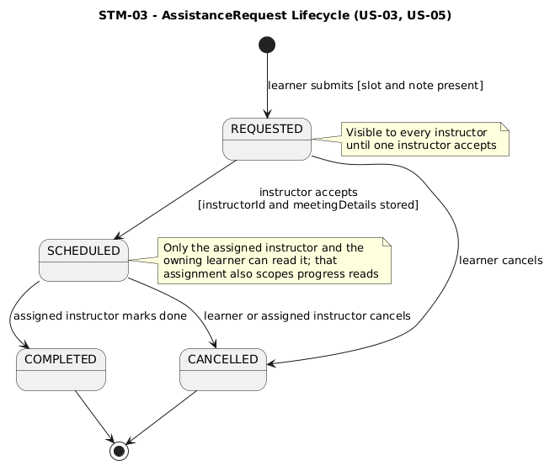

Figure STM-03 - AssistanceRequest Lifecycle (US-03, US-05: REQUESTED, SCHEDULED, COMPLETED or CANCELLED, with instructor assignment)

4. Data Design

4.1 Overview
PracticeMode uses a relational data model stored in PostgreSQL to support the MVP user stories. The model covers users and access sessions, practice forms and their fields, guidance content, form review records, learner attempts and answers, assistance requests, and learner progress.
The UML domain model (DM-01) shows the main entities and their relationships. The following subsections define their key attributes and constraints, including required fields, unique values, and valid states.

4.2 UML Domain Model Diagram
Figure DM-01 shows the main entities required by the PracticeMode MVP, their key attributes, and their relationships. Multiplicities indicate how many records can participate in each relationship. Session represents an authenticated access session, not a workshop.
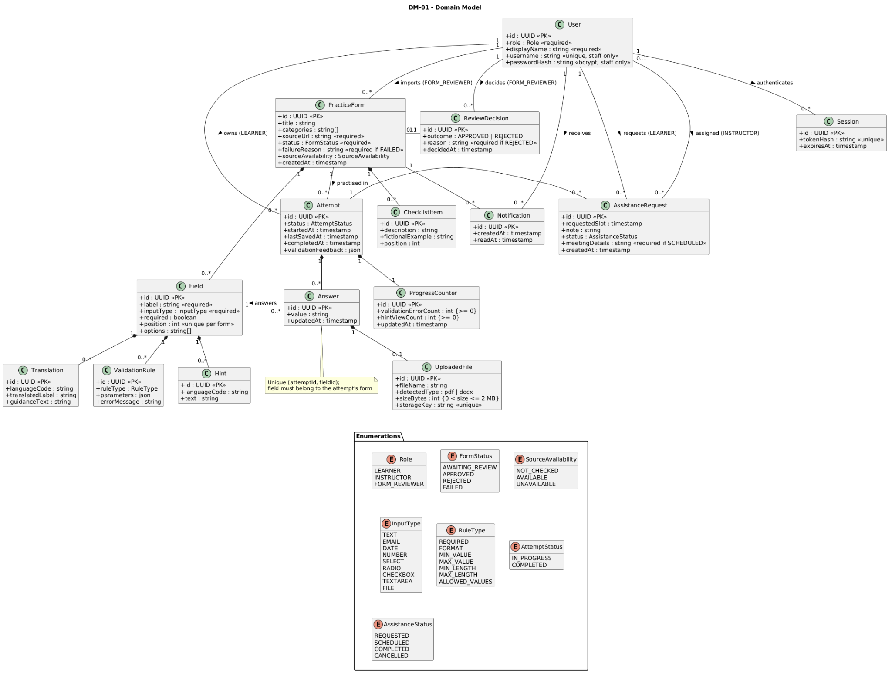
Figure DM-01. PracticeMode UML Domain Model

4.3 Key Attributes and Constraints
Each entity has a UUID primary key (id). Required attributes cannot be null, and required text values cannot be blank. Foreign keys must reference existing records. Optional attributes may be null when their information is not yet available.
The relationships shown in DM-01 are implemented using the foreign keys listed below.

Entity | Key attributes | Constraints
User | id, role, displayName, username, passwordHash | role must be LEARNER, INSTRUCTOR, or FORM_REVIEWER. A display name is required. Learners have no username or password hash. Staff require a unique username and a bcrypt password hash with cost 10 or higher. Display names do not have to be unique.
Session | id, userId (FK), tokenHash, expiresAt | All attributes are required. tokenHash must be unique. Expired sessions cannot authorize requests. This entity represents authenticated access, not a workshop.
PracticeForm | id, importedById (FK → User), title, categories, sourceUrl, status, failureReason, sourceAvailability, createdAt | Importer, source URL, status, and creation time are required. The importer must be a Form Reviewer. Status must be AWAITING_REVIEW, APPROVED, REJECTED, or FAILED. Failed extraction requires a failure reason. A successfully extracted form requires a title and at least one field. Categories cannot contain blank or duplicate values. Source availability is recorded as NOT_CHECKED, AVAILABLE, or UNAVAILABLE; it does not automatically imply approval.
Field | id, formId (FK → PracticeForm), label, inputType, required, position, options | Form, label, input type, required flag, and position are mandatory. Position must be positive and unique within the form. Supported input types are TEXT, EMAIL, DATE, NUMBER, SELECT, RADIO, CHECKBOX, TEXTAREA, and FILE. Choice-based fields require non-empty, non-duplicate options where applicable.
ValidationRule | id, fieldId (FK → Field), ruleType, parameters, errorMessage | Field, rule type, and error message are required. Rule types are restricted to implemented validators, such as REQUIRED, FORMAT, MIN_VALUE, MAX_VALUE, MIN_LENGTH, MAX_LENGTH, and ALLOWED_VALUES. Parameters must match the selected rule type. Rules must agree with the field’s input type and required flag.
Hint | id, fieldId (FK → Field), languageCode, text | All attributes are required. The combination of field and language code must be unique. A missing hint is represented by no record.
Translation | id, fieldId (FK → Field), languageCode, translatedLabel, guidanceText | Field and supported language code are required. At least one of translated label or guidance text must be present. The combination of field and language code must be unique. Missing translated content falls back to the original content and is identified as unavailable. Original field labels are preserved.
ChecklistItem | id, formId (FK → PracticeForm), description, fictionalExample, position | Form, description, and position are required. Position must be positive and unique within the form. Examples are optional but, when present, must contain fictional information and be displayed as such.
ReviewDecision | id, formId (FK → PracticeForm), reviewerId (FK → User), outcome, reason, decidedAt | Form, reviewer, outcome, and timestamp are required. The reviewer must have the Form Reviewer role. Outcome must be APPROVED or REJECTED; rejection requires a reason. Each form has at most one final decision in the MVP. The decision and corresponding form status are saved in one transaction.
Notification | id, formId (FK → PracticeForm), recipientId (FK → User), createdAt, readAt | Form, recipient, and creation time are required. The recipient must be a Form Reviewer. One pending-review notification is stored per form and recipient. readAt is optional and cannot precede createdAt.
Attempt | id, learnerId (FK → User), formId (FK → PracticeForm), status, startedAt, lastSavedAt, completedAt, validationFeedback | Learner, form, status, and start time are required. The owner must have the Learner role. The form must be APPROVED when the attempt starts. Proposed states are IN_PROGRESS and COMPLETED. Completion requires a completion timestamp and stored feedback, which may be an empty list. Save and completion timestamps cannot precede the start time.
Answer | id, attemptId (FK → Attempt), fieldId (FK → Field), value, updatedAt | Attempt, field, and update time are required. The pair (attemptId, fieldId) must be unique. The field must belong to the attempt’s form. Values must use a representation compatible with the input control; incomplete or rule-invalid draft answers can be saved for later feedback. Answers can be changed only while the attempt is IN_PROGRESS.
UploadedFile | id, answerId (FK → Answer), fileName, detectedType, sizeBytes, storageKey | All attributes are required. answerId is unique, allowing at most one current file per answer. The associated field must have input type FILE. Only server-validated PDF or DOCX files are accepted, with size greater than zero and no larger than 2 MB. storageKey must be unique and refer to private application-controlled storage.
AssistanceRequest | id, attemptId (FK → Attempt), learnerId (FK → User), instructorId (optional FK → User), requestedSlot, note, status, meetingDetails, createdAt | Attempt, learner, requested slot, note, status, and creation time are required. The learner must own the attempt. The related form is obtained through that attempt. An assigned user must have the Instructor role. Proposed states are REQUESTED, SCHEDULED, COMPLETED, and CANCELLED. SCHEDULED requires an instructor and meeting details.
ProgressCounter | id, attemptId (unique FK → Attempt), validationErrorCount, hintViewCount, updatedAt | Each attempt has exactly one progress record, created with the attempt. Counters are required, start at zero, and cannot be negative. Hint counts increase only for recorded hint-opening actions. Validation error counts reflect recorded validation results. Retries must not count the same activity twice. Incomplete attempts are calculated from attempt status.

Cross-entity consistency
- Role and ownership checks are enforced by the server. Instructors can access progress only for learners within the authorization scope defined in DD-02.
- Answer-to-field consistency must be checked before saving: an answer cannot reference a field from a different practice form.
- Referenced form definitions and fields cannot be deleted or changed in a way that invalidates existing attempts. Changes requiring a different structure must use a new form record.
- Completing an attempt saves its outcome, feedback, and related progress updates together. Repeated completion requests must not create duplicate results.
- Database constraints enforce primary keys, foreign keys, uniqueness, and simple value checks. The server enforces role checks, permitted state transitions, and rules involving multiple entities.

4.4 Data Integrity and Business Rules
- Required and unique values: Each entity has a unique primary key. Mandatory attributes cannot be null or empty. Each field has a unique position within its practice form.
- User identity: Learners provide a display name without an email or password. Display names do not have to be unique; internal identifiers distinguish learners. Staff passwords are stored only as bcrypt hashes.
- Form availability: PracticeForm status must be AWAITING_REVIEW, APPROVED, REJECTED, or FAILED. New attempts can be created only for forms with status APPROVED.
- Review decisions: Only authorized Form Reviewers can approve or reject a form awaiting review. Each decision records the reviewer, outcome, and timestamp. Rejection requires a non-empty reason. The decision and form status are saved together.
- Answer consistency: Each attempt belongs to one learner and one practice form. Each answer belongs to one attempt and one field from that same form. The combination of attemptId and fieldId must be unique.
- Draft persistence: A successful save updates the answer and its save timestamp. A failed save preserves the previously stored answer and must not be recorded as a successful save or completion.
- Completion and validation: Completion checks answers against the form’s stored validation rules and records the outcome and available field feedback. A completed attempt cannot be completed again. A save failure is separate from a validation error.
- Guidance content: Hints, translations, and checklist items belong to their relevant field or form. Missing content remains unavailable rather than being fabricated. Viewing guidance or changing its language must not modify saved answers. Checklist examples must be clearly identified as fictional.
- Assistance requests: Each request references the learner, attempt, and associated form. Required scheduling details must be present before creation. An assigned instructor must have the Instructor role; access follows the ownership rules defined in DD-02.
- Progress records: Progress measures must reflect recorded attempts, errors, and hint usage. Counters cannot be negative, and retrying the same operation must not count the same activity twice.
- Practice privacy: Practice answers and uploaded files remain within PracticeMode and are never sent to the original source website. File uploads must pass server-side content validation and be PDF or DOCX files no larger than 2 MB.

5. Interface Design
PracticeMode is a web application in which the browser client communicates with the Django server over HTTP interfaces. The interfaces defined in this section support the two primary workflows established in Sprint 1: the learner practice workflow and the Form Reviewer workflow.
All authorization is enforced by the server rather than solely through the user interface. Sprint 1 requires the server to verify both the caller's role and their ownership of the requested resource on every protected request. Only Form Reviewers may approve or reject extracted forms, and learners may access only their own practice attempts. Hiding a control in the interface is therefore a usability measure, never the security boundary.

5.1 API Interface Summary
Each interface is identified by an API ID and traced to the Sprint 1 user stories it supports. Error responses follow standard HTTP status semantics:
- 400 for malformed or missing input,
- 401 for unauthenticated callers,
- 403 for authenticated callers who lack the required role or ownership,
- 404 for resources that do not exist,
- 409 for a request that conflicts with the current state,
- 503 when the server cannot persist data.

5.1.1 Authentication and learner interfaces
ID | Endpoint | Inputs | Successful output | Error responses | Allowed caller | Stories
API-01 | POST  /api/login | username, password, or valid role/access credentials | Authenticated session and the user's role | 400 required input missing  401 invalid credentials | Any PracticeMode user | US-01
API-02 | GET  /api/forms | Optional keyword and category filters | List of matching approved practice forms | 400 invalid filter values | Learner | US-02
API-03 | GET  /api/forms/{formId} | formId | Practice form definition: field labels, controls, options, hints and available translations | 403 form not available for practice  404 form does not exist | Learner | US-09, US-11, US-12, US-18
API-04 | POST  /api/attempts | formId, learner display name | New practice attempt and generated attemptId | 400 invalid input  403 form not approved  404 form does not exist | Learner | US-11
API-05 | GET  /api/attempts/{attemptId} | attemptId | Current practice attempt, including previously saved answers | 403 attempt belongs to another learner  404 attempt does not exist | Learner who owns the attempt | US-08, US-11
API-06 | PATCH  /api/attempts/{attemptId}/answers/{fieldId} | fieldId, value | Saved answer and save timestamp | 400 invalid value  403 unauthorized attempt  404 missing attempt or field  503 save failed | Learner who owns the attempt | US-08, US-11

5.1.2 Form Reviewer interfaces
ID | Endpoint | Inputs | Successful output | Error responses | Allowed caller | Stories
API-07 | GET  /api/review/forms | Optional review status, e.g. AWAITING_REVIEW | List of extracted forms requiring human review | 401 signed out  403 incorrect role | Form Reviewer | US-04, US-16
API-08 | GET  /api/review/forms/{formId} | formId | Extracted field definition, source URL and current review status | 403 incorrect role  404 form does not exist | Form Reviewer | US-04, US-10, US-16
API-09 | POST  /api/review/forms/{formId}/decision | decision = APPROVE or REJECT, with a rejection reason where applicable | Updated review status, reviewer identity and review timestamp | 400 invalid decision  403 incorrect role  404 form does not exist  409 already reviewed | Form Reviewer | US-17
API-10 | GET  /api/review/notifications | None | Pending form review notifications | 401 signed out  403 incorrect role | Form Reviewer | US-16

5.2 Interface Constraints and Rules
Three rules constrain how these interfaces may be used. Each follows directly from a decision or requirement recorded in Sprint 1, and each is enforced on the server so that it holds regardless of how the client behaves.

Rule 1 – Approved forms only
A new learner practice attempt may be created only when the selected PracticeForm has status APPROVED. A form whose status is AWAITING_REVIEW, REJECTED or FAILED cannot be used to create a practice attempt. This follows the Sprint 1 decision that an unchecked extracted form could teach incorrect information, so normal learner use begins only after human review.
Example request
POST /api/attempts
{
"formId": 27,
"displayName": "Alex"
}
Response when form 27 has not yet been approved
403 Forbidden
{
"error": "FORM_NOT_APPROVED",
"message": "This form is not available for practice yet."
}

Rule 2 – Autosave confirmation
A field is displayed as saved only after the Django server confirms that the answer has been stored. The client never reports success on its own. This supports US-08, because learners must not lose progress without being told (Sprint 1 Requirements, US-08).
Example request
PATCH /api/attempts/42/answers/7
{
"value": "Alex Morgan"
}
Successful response – the interface displays "Saved ✓"
200 OK
{
"fieldId": 7,
"value": "Alex Morgan",
"savedAt": "2026-10-19T18:24:00Z"
}
Failed save – the interface displays "Not saved. Retry."
503 Service Unavailable
{
"error": "SAVE_FAILED",
"message": "Your answer could not be saved. Please retry."
}

Rule 3 – Server-side reviewer permission
Reviewer actions are authorized by the Django server even when the corresponding control is hidden in the user interface. This follows the Sprint 1 permission requirement that only a Form Reviewer may edit, approve or reject a form (Sprint 1 Requirements, US-17).
Unauthorized call
POST /api/review/forms/27/decision
Response
403 Forbidden
{
"error": "REVIEWER_PERMISSION_REQUIRED"
}

6. Key Behaviors
Sequence diagrams are used to document the main behaviors because these flows depend on the order in which the user interface, the Django server and the database interact. As described in the Week 4 lecture notes, a sequence diagram is an interaction diagram that shows how objects collaborate over time through lifelines, messages, activations and conditions (Week 4 lecture notes – use case and sequence diagrams).
For PracticeMode, the two most complex MVP flows are learner practice with autosave (Section 6.1) and extracted-form human review (Section 6.2). A state machine is additionally used for the PracticeForm lifecycle (Section 6.3), because the form's current state determines whether learners may use it.

6.1 Learner Practice and Autosave
Supports US-08, US-11 and US-12.
The learner opens an approved practice form. The browser requests the form from the Django server, which retrieves the approved form definition from the database, and the browser then displays the fields, hints and controls.
When the learner changes an answer, the client sends an autosave request. Before saving the value, the server verifies that the learner owns the practice attempt. The diagram includes a failure path because the interface must not display a success message unless the server has confirmed that the answer was stored. The alternative (alt) fragment reflects the lecture-note convention that conditions are used when messages are sent only under certain circumstances.
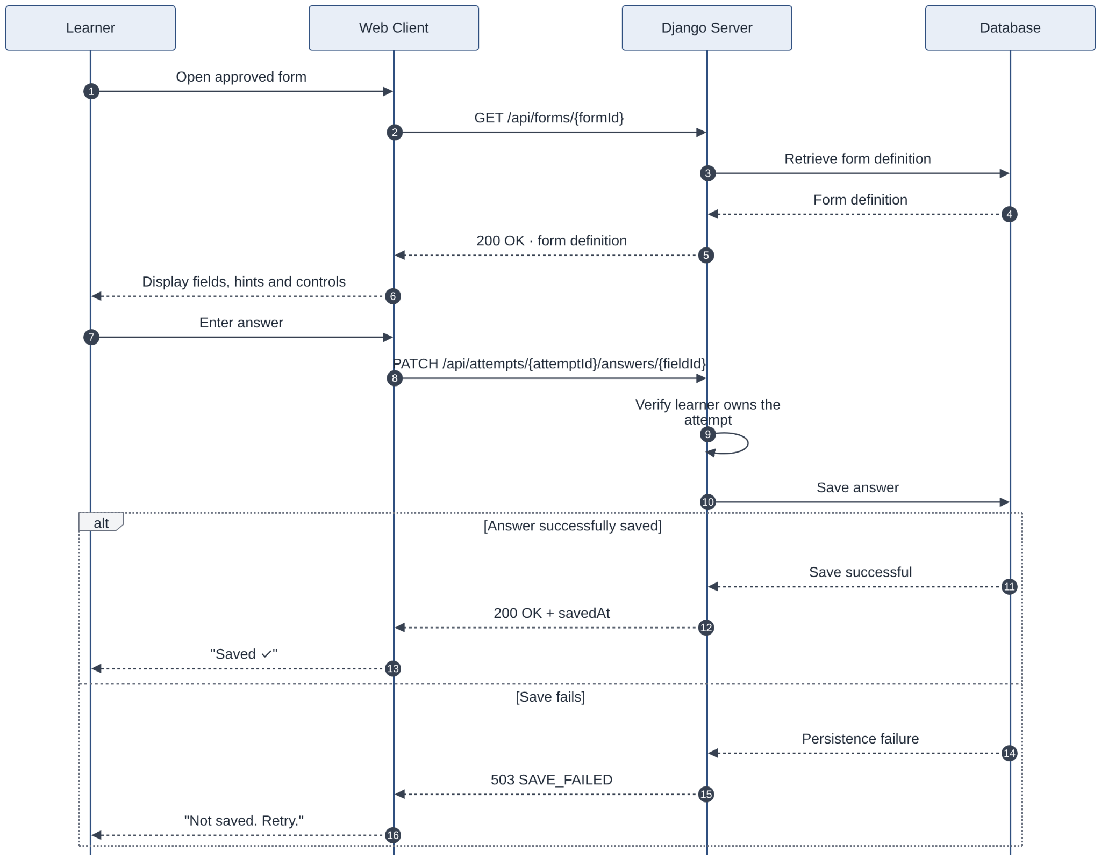
Figure SQ-02 – Learner Practice and Autosave Sequence (US-08, US-11, US-12): loading an approved practice form, entering an answer, and confirming successful persistence, with a save-failure path.

6.2 Extracted Form Human Review
Supports US-04, US-10, US-16 and US-17.
After the system extracts a supported source form, the resulting PracticeForm is stored with status AWAITING_REVIEW and a review notification is created so that an authorized Form Reviewer knows that verification is required. Sprint 1 requires every newly extracted form to generate a review notification, and every reviewer decides to record the reviewer's identity and the time of review (Sprint 1 Requirements, US-16 and US-17).
The Form Reviewer opens the review queue, selects the extracted form, compares its fields with the original source URL, and records either an approval or a rejection. The server checks the caller's role before storing the decision; a caller without the Form Reviewer role receives 403 Forbidden, which supports the Sprint 1 permission requirement that only an authorized Form Reviewer may approve or reject a form.
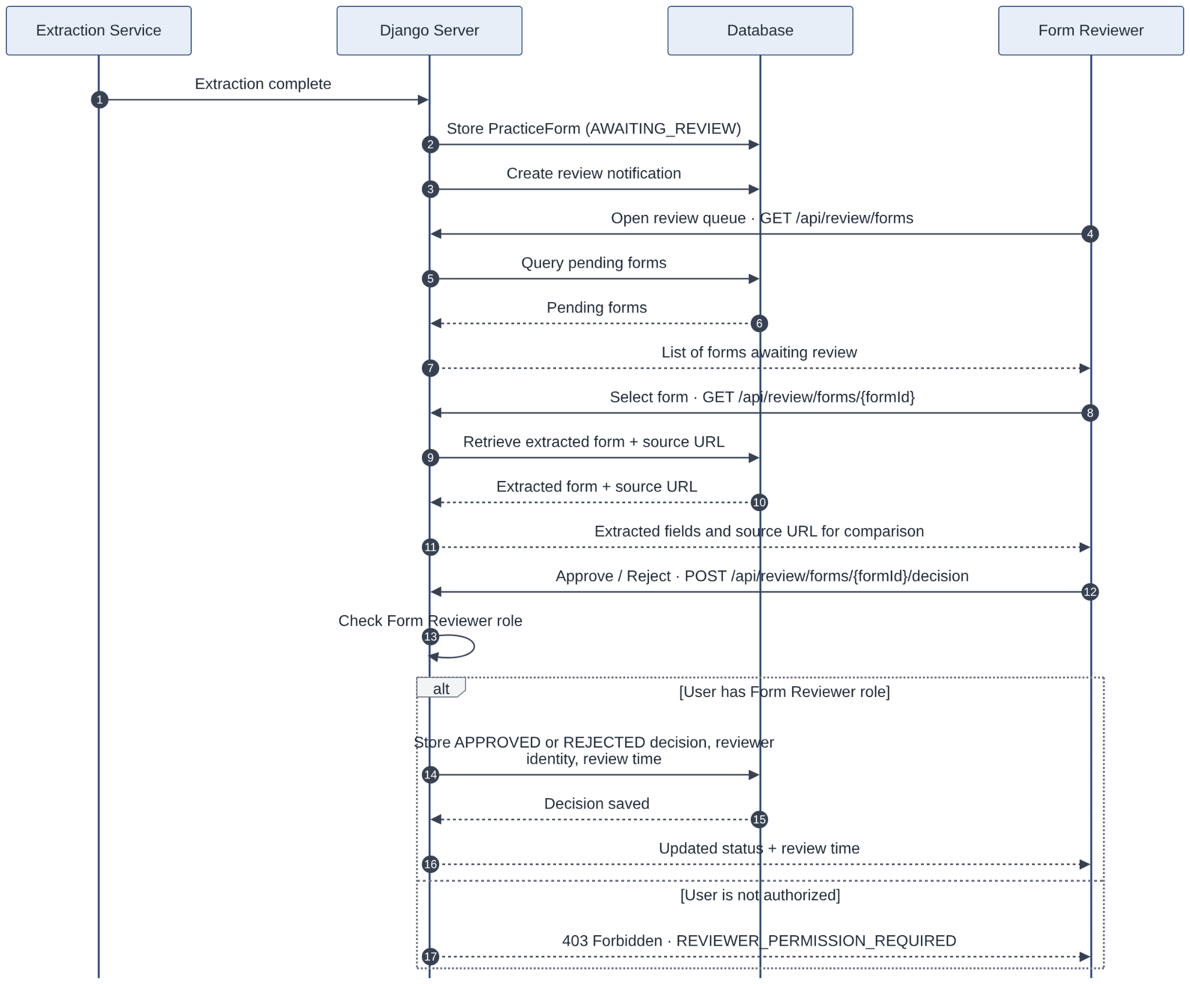
Figure SQ-03 – Extracted Form Human Review Sequence (US-04, US-10, US-16, US-17): reviewer notification, comparison with the original source, approval or rejection, and unauthorized-access handling.

6.3 PracticeForm Lifecycle
Supports US-04, US-16 and US-17.
A state machine is used for PracticeForm because the form has a meaningful lifecycle and its current state determines whether learners can use it. A form enters the system as NEW, moves to EXTRACTING while its source is processed, and then either reaches AWAITING_REVIEW or terminates in FAILED. A human review decision moves an awaiting form to APPROVED or REJECTED.
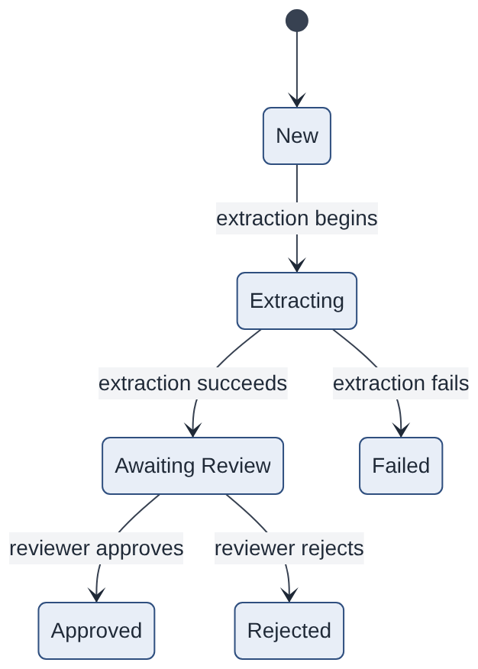
Figure STM-01 – PracticeForm Review Lifecycle (US-04, US-16, US-17): an extracted form becomes available for practice only after successful human review and approval.

State rules
State | Meaning | Learner may start a new attempt?
NEW | Form record has been created | No
EXTRACTING | Source form is being processed | No
AWAITING_REVIEW | Extraction succeeded but human verification has not yet occurred | No
APPROVED | Reviewer verified the form | Yes
REJECTED | Reviewer determined that the extracted form is unsuitable | No
FAILED | Extraction failed or could not be completed | No
Only forms in the APPROVED state are available for new learner practice attempts. A rejected form must remain unavailable for new attempts, as stated directly in US-17 (Sprint 1 Requirements, US-17).

7. Design Decisions

This section records the choices we still had to make after the architecture chapter. We kept the modules, API-01 through API-10, and figures Figure 2.1 and Figure 2.2. The server is the Django server named in section 5. Each record has the situation we were in, the options we actually had, the choice we made, and what that choice costs us.

DD-01. Which UML views to draw

Context. Figure 2.1 already shows the modules and the line between practice and extraction. Figure 2.2 already shows the browser, the single application server, PostgreSQL, and the source site. Those two figures do not show that a learner can start an attempt only when the form is APPROVED. They also do not show that saving one field is a different step from finishing the attempt. The story table has to point at a diagram for every MVP story. Drawing a new picture for every screen would mostly repeat Figure 2.1.

Options considered:

1. Point every story at Figure 2.1 and Figure 2.2 only.
2. Draw a use case, class, sequence, activity, and state diagram for all 26 stories, including stretch and out of scope.
3. Keep Figure 2.1 and Figure 2.2, and add a small set of UML diagrams for the behavior those two figures cannot show.

Decision: We chose option 3. The list is under "Why and where we use UML" below. On the form state machine we kept the status names from the interface rules: AWAITING_REVIEW, APPROVED, REJECTED, and FAILED.

Consequences: We left screen layout out of the model. Stretch stories do not have their own figure. US-03, US-05, and US-22 are covered by UC-03, SQ-04, and Figure 2.1, so we did not draw a separate picture for each filter. The behavioral figures named in the matrix (UC-01 to UC-04, SQ-01 to SQ-04, STM-01 to STM-03, ACT-01) are all in Section 3 and Section 6.

DD-02. Permissions are checked in the Authentication and Authorization Module

Context: The permissions NFR says the server checks role and ownership on every request. An instructor can read or change only their own records. Only a Form Reviewer can approve or reject a form. A learner can read or change only their own attempt. The architecture already says the React screens are not where this check lives. We still had not defined what "authorized" means for an instructor. Workshop codes are out of scope, so we cannot treat ownership as "the learners in my workshop."

Options considered:

1. Hide buttons in the Role-Based Web Interface and trust the browser.
2. Check the role only, which would let any instructor open any learner's attempt and progress.
3. Send every protected call through the Authentication and Authorization Module first. The module checks the role and a stored owner, then calls Catalog, Review, Practice, Assistance, or Progress. If a route has no rule, the call fails closed.

Decision: We chose option 3.

A learner can read or write an attempt, an answer, a completion, and a help request only when that row stores their identity.

A Form Reviewer can import, inspect, decide, and read review notifications. A reviewer cannot read attempt answers.

A help request shows up for every instructor until one instructor id is stored on it. After that, only that instructor and that learner can read it. Another instructor gets 403, and the body does not include the request fields. Progress rows exist only for learners who have a request assigned to that instructor.

If there is no session, the response is 401. If the role or the owner is wrong, the response is 403, and the body does not include the form, the attempt, or the request. If someone tries to decide a form that already has a decision, the response is 409 and the stored status stays as it is.

Consequences: The permission tests have to cover API-11 through API-16 as well as API-01 through API-10. Until an instructor id is stored, every instructor can see that request. The progress screen cannot show a learner who never asked for help. Reviewers never see answers. A hidden button in React can drift away from the module. The API tests are what catch a missing check on the server.

DD-03. The browser extension extracts the source form

Context: PracticeMode must extract supported form structures from external websites without transferring Learner practice answers to those websites. The architecture separates form extraction from Learner practice and requires extracted forms to undergo human review before publication.

Options considered:

- Use a browser extension to read supported form fields from the active external webpage and send the extracted metadata to Django.
- Use the Django backend to fetch and parse a source URL directly.
- Support both browser-extension and server-side extraction.
Decision: The team selected Option 1. An authorized Form Reviewer uses the browser extension to extract supported form metadata. The extension sends the source URL, field labels, input types, options, and supported validation attributes to Django through an authenticated HTTPS API (API-15). Django verifies Reviewer permissions, validates and normalizes the payload, and stores a successful import as AWAITING_REVIEW. Unsupported or invalid imports are rejected or recorded as FAILED according to the API contract. Only forms approved by a Form Reviewer become available for Learner practice.
Consequences: The extension requires separate development, browser permissions, and testing. Extraction is limited to supported webpages and browser environments. Django must treat incoming extension data as untrusted and prevent unauthorized imports. The extension must not capture or transmit Learner practice answers. This approach adds client-side complexity but avoids placing webpage-scraping logic in the Django backend.
Requirements impact: Browser-extension extraction changes the implementation approach previously documented in Sprint 1. The team must record this scope decision and reconcile US-25 and the accepted Sprint 1 requirements baseline before treating the extension as an approved MVP requirement.

DD-04. One process, and extraction stays off the practice path

Context. The architecture uses one application server and one PostgreSQL database, and it does not split the work into a separate service per module. The performance NFR, with 30 learners at once, asks for 95% of practice page loads under 2 seconds, 95% of answer saves under 1 second, the instructor report under 2 seconds, and extraction finished or failed within 15 seconds. Although the browser extension performs webpage extraction, Django must still validate and store imported form metadata. Import processing must remain separate from Learner practice operations so that large or invalid extraction payloads do not delay answer saves or form loading.

Options considered:

1. Split extraction into its own service. That would isolate a slow fetch, and it would change the deployment figure we already chose.
2. Validate and store imports on the same request path as learner practice calls.
3. Keep a single Django backend and PostgreSQL database. The browser extension performs extraction, while Django handles metadata validation and import through a separate API request. Learner practice uses stored, approved forms and never waits for extraction. Progress reports use stored activity counts.

Decision: We chose option 3. Opening a form loads one approved definition. Saving a field updates one answer row and returns the timestamp, or it tells the learner that the save was not confirmed. Completing an attempt is a separate call that records the feedback. Progress counts move when an attempt is completed and when a hint is opened.

Consequences: Import validation and persistence share the Django backend with Learner requests, so large or slow imports must not block practice operations. The team cannot scale import processing independently without additional infrastructure. Database indexing and efficient queries are necessary to meet the Sprint 1 response-time targets. Extraction timing and 30-Learner performance will be tested separately, including the 15-second extraction requirement where applicable.

DD-05. The server is Django, and the interface table covers every MVP story

Context: The component table assigns help requests, progress tracking, form import, and attempt completion to application modules. The interface specification in Section 5 defines API-01 through API-10; API-11 through API-16 are defined in this decision record and must also be incorporated into the complete interface specification.

Options considered:

1. Keep the interface table at API-01 through API-10 and leave help requests, progress, import, and completion without an interface row.
2. Keep Django, as written in section 5. Keep API-01 through API-10, and add API-11 through API-16 in the same columns. The form read response also includes the checklist, or an explicit empty list.

Decision: We chose option 2. The backend is Django. Staff sign in on API-01 with a username and a password. The password is stored only as a bcrypt hash, at cost 10 or higher. A learner signs in on the same API-01 with a display name and no password. Both receive an HttpOnly, Secure cookie over HTTPS.

Id | Endpoint | Method | Allowed caller | Stories
API-11 | /api/assistance-requests | POST | Learner who owns the attempt | US-03
API-12 | /api/assistance-requests | GET | Instructor | US-05
API-13 | /api/assistance-requests/{requestId} | GET | Assigned instructor, or the owning learner | US-03, US-05
API-14 | /api/progress | GET | Instructor, assigned learners only | US-22
API-15 | /api/forms/extractions | POST | Form Reviewer | US-25
API-16 | /api/attempts/{attemptId}/completion | POST | Learner who owns the attempt | US-26

If the time slot or the note is missing on API-11, no row is created. API-16 returns field feedback for that attempt only. When a file field is saved through the answer route, Django checks the bytes. A PDF has to start with %PDF. A DOCX has to be a zip that contains [Content_Types].xml. The file has to be 2 MB or smaller.

Inputs, outputs and error responses for API-11 to API-17 (same status semantics as Section 5.1; every route returns 401 with no session, and a 403 body never includes the protected record):

API-11 POST /api/assistance-requests. Inputs: attemptId, requestedSlot, note. Output: 201 with requestId, status REQUESTED, attemptId, formId, createdAt. Errors: 400 missing slot or note; 403 the attempt belongs to another learner or the caller is not a Learner; 404 attempt does not exist; 409 the attempt already has an open request; 503 row could not be saved.

API-12 GET /api/assistance-requests. Inputs: optional status filter (REQUESTED or SCHEDULED). Output: 200 list of the requests visible to the caller (every REQUESTED request, plus the requests assigned to this instructor), each with requestId, learner display name and short code, form title, requestedSlot, status. Errors: 400 invalid status value; 403 caller is not an Instructor.

API-13 GET /api/assistance-requests/{requestId}. Inputs: requestId. Output: 200 request detail: note, requestedSlot, status, meetingDetails, assigned instructor, form title, attemptId. Errors: 403 caller is neither the owning learner nor the assigned instructor (or, while the request is unassigned, any instructor); 404 request does not exist.

API-14 GET /api/progress. Inputs: optional filters incomplete=true, minErrors, minHints, formId. Output: 200 rows of learner display name and short code, form title, attempt status, validationErrorCount, hintViewCount, lastSavedAt, limited to learners who have a request assigned to the caller. Errors: 400 invalid filter value; 403 caller is not an Instructor.

API-15 POST /api/forms/extractions (called by the browser extension). Inputs: sourceUrl, title, fields[] with label, inputType, required, position, options and validation attributes. Output: 201 with formId and status AWAITING_REVIEW; a review notification is created. Errors: 400 payload invalid (missing title or fields, unsupported inputType, duplicate position); 403 caller is not a Form Reviewer; 409 a form for the same sourceUrl is already awaiting review; 422 structure unsupported, recorded as FAILED with failureReason; 503 could not be stored.

API-16 POST /api/attempts/{attemptId}/completion. Inputs: attemptId (no body). Output: 200 with status COMPLETED, completedAt and validationFeedback[] of fieldId, ruleType, errorMessage; the ProgressCounter is updated in the same transaction. Errors: 403 the attempt belongs to another learner; 404 attempt does not exist; 409 attempt already COMPLETED, the stored result is returned and nothing is duplicated; 503 feedback could not be saved.

API-17 PATCH /api/assistance-requests/{requestId}/schedule (added so the REQUESTED to SCHEDULED transition in STM-03 has an interface; supports US-05). Inputs: meetingDetails. Output: 200 with status SCHEDULED, instructorId and meetingDetails. Errors: 400 missing meeting details; 403 caller is not an Instructor; 404 request does not exist; 409 the request is already SCHEDULED by another instructor.

Consequences: On Django, the same cases run through Django's test client. The answer route stays a save. If we used that same route for completion, a failed save and a validation message would look the same. A learner who loses the cookie cannot get the draft back, because storing an email for recovery would break the privacy rule.

Why and where we use UML

Use case diagrams show which actor can reach which MVP behavior. UC-01 is access for the Learner, the Instructor, and the Form Reviewer. UC-02 is the learner practice path: search, open an approved form, hints, translation, checklist, save, and complete. UC-03 is the instructor path, which is help requests and progress filters. UC-04 is the reviewer path: import, queue, source check, notification, and approve or reject. The boundary of each diagram is the PracticeMode server. The source website sits outside that boundary, and only the extraction flow touches it.

The class diagram, DM-01, fixes the nouns we are allowed to store: User, Session, PracticeForm, Field, Hint, Translation, ChecklistItem, ValidationRule, ReviewDecision, Notification, Attempt, Answer, AssistanceRequest, and ProgressCounter. A learner User has a display name and no password hash. A staff User has a bcrypt hash. Hint and Translation are optional. We do not have a class for a copied web page.

We use sequence diagrams where the order of the calls decides whether the story is met. SQ-01 is sign-in, and then a learner stopped before the review module runs. SQ-02 is open, save one field, then complete, with no call to the source site. SQ-03 is extract, notify, inspect the source URL, then approve or reject. SQ-04 is a help request, and a progress read limited to the assigned instructor.

We use state machines where a status changes what a later call is allowed to do. STM-01 is the form, with the states AWAITING_REVIEW, APPROVED, REJECTED, and FAILED. Only APPROVED allows a new attempt. STM-02 is the attempt: in progress, save not confirmed, and completed. Opening or closing a hint does not change the attempt state. STM-03 is the assistance request: REQUESTED, SCHEDULED, COMPLETED, or CANCELLED; only a SCHEDULED request is visible to its assigned instructor and its learner.

ACT-01 is the search flow. We drew it as an activity because it is a decision path, not a conversation between modules. The learner enters a keyword and one or more categories. The result is approved forms only. If nothing matches, the page shows an empty result and says so.

Figure 2.1 stays the component view. Figure 2.2 stays the deployment view. The box on Figure 2.2 is the Django server. We did not redraw the figures under a second pair of names.

We did not draw a sequence for screen layout, for the inside of a React component, or for stretch and out of scope stories. Those pictures would not change the module boundary or the status rules.

Id | View | Stories it realizes
UC-01 | Use case | US-01
UC-02 | Use case | US-02, US-08, US-09, US-11, US-12, US-18, US-26
UC-03 | Use case | US-03, US-05, US-22
UC-04 | Use case | US-04, US-10, US-16, US-17,US-25
SQ-01 | Sequence | US-01
SQ-02 | Sequence | US-08, US-09, US-11, US-12, US-26
SQ-03 | Sequence | US-04, US-10, US-16, US-17, US-25
SQ-04 | Sequence | US-03, US-05, US-22
STM-01 | State machine | US-04, US-11, US-16, US-17, US-25
STM-02 | State machine | US-08, US-26
ACT-01 | Activity | US-02
DM-01 | Class | All MVP stories that store a row
Figure 2.1 | Component | All MVP stories
Figure 2.2 | Deployment | US-01, US-25, and the privacy and security NFRs

8. Traceability

This section maps every MVP story to the components, interfaces, and diagrams that realize it, and maps every Sprint 1 NFR to the design mechanism and the test that checks it. The calls are served by Django. API-01 through API-10 are the interface rows already in section 5. API-11 through API-17 are the rows added in DD-05, with their inputs, outputs and error responses listed below that table. US-25 is traced to the Form Reviewer import, because that is how the component table assigns it.

MVP stories

Workflow | Story | Components | Interface | Diagrams | Domain classes | Notes
Access | US-01 | Role-Based Web Interface, Authentication and Authorization Module, PostgreSQL Database | API-01 | UC-01, SQ-01, Figure 2.1, Figure 2.2 | User, Session | Staff password or learner display name. A wrong caller never receives a protected payload.
Find and practice | US-02 | Role-Based Web Interface, Form Catalog Module, Authentication and Authorization Module, PostgreSQL Database | API-02 | UC-02, ACT-01, Figure 2.1 | PracticeForm | Keyword and several categories. Results are APPROVED only. If nothing matches, the list is empty.
Find and practice | US-08 | Role-Based Web Interface, Practice Attempt Module, Authentication and Authorization Module, PostgreSQL Database | API-05, API-06 | UC-02, SQ-02, STM-02, Figure 2.1 | Attempt, Answer | Reopen returns the last confirmed answers. A failed save is reported on its own, and it is not worded as validation feedback.
Find and practice | US-09 | Role-Based Web Interface, Guidance Module, PostgreSQL Database | API-03 | UC-02, SQ-02, DM-01 | Field, Translation | The selected language is shown beside the original label. A missing translation is marked unavailable. Answers are left as the learner typed them.
Find and practice | US-11 | Role-Based Web Interface, Practice Attempt Module, Authentication and Authorization Module, PostgreSQL Database | API-03, API-04, API-05, API-06 | UC-02, SQ-02, STM-01, Figure 2.1 | PracticeForm, Field, Attempt, Answer | The page renders the stored fields. A form that is not APPROVED cannot start an attempt.
Find and practice | US-12 | Role-Based Web Interface, Guidance Module, PostgreSQL Database | API-03 | UC-02, SQ-02, DM-01 | Field, Hint | A stored hint can be opened without changing the answer. If there is no hint, nothing is invented.
Find and practice | US-18 | Role-Based Web Interface, Guidance Module, PostgreSQL Database | API-03 | UC-02, DM-01, Figure 2.1 | ChecklistItem | Samples are marked fictional. If there is no checklist, the list is empty and the page says so.
Find and practice | US-26 | Role-Based Web Interface, Practice Attempt Module, Learner Progress Module, Authentication and Authorization Module, PostgreSQL Database | API-16 | UC-02, SQ-02, STM-02, Figure 2.1 | Attempt, ValidationRule, ProgressCounter | Completion records the outcome and names each field that broke a stored rule.
Instructor Support | US-03 | Role-Based Web Interface, Instructor Assistance Module, Authentication and Authorization Module, PostgreSQL Database | API-11, API-13 | UC-03, SQ-04, Figure 2.1 | AssistanceRequest, Attempt, PracticeForm | The request stores the form and the attempt. A missing slot or note creates no row.
Instructor Support | US-05 | Role-Based Web Interface, Instructor Assistance Module, Authentication and Authorization Module, PostgreSQL Database | API-12, API-13, API-17 | UC-03, SQ-04, Figure 2.1 | AssistanceRequest | The instructor sees the queue and the requests assigned to them, including the form and the meeting details. Another instructor's assigned request returns an empty 403.
Instructor Support | US-22 | Role-Based Web Interface, Learner Progress Module, Authentication and Authorization Module, PostgreSQL Database | API-14 | UC-03, SQ-04, Figure 2.1 | ProgressCounter, User | Filters are incomplete attempts, errors, and hint use, limited to learners assigned to that instructor.
Review and import | US-04 | Role-Based Web Interface, Form Review Module, Authentication and Authorization Module, PostgreSQL Database | API-07, API-08 | UC-04, SQ-03, STM-01, Figure 2.1 | PracticeForm, Field, ValidationRule | The queue shows forms waiting for review. The preview includes labels, input types, required flags, and validation.
Review and import | US-10 | Role-Based Web Interface, Form Review Module, Authentication and Authorization Module, PostgreSQL Database | API-08 | UC-04, SQ-03, Figure 2.1 | PracticeForm | The stored source URL is available for comparison. A source that cannot be reached is recorded as unavailable. It is not treated as verified.
Review and import | US-16 | Role-Based Web Interface, Form Review Module, Authentication and Authorization Module, PostgreSQL Database | API-07, API-10 | UC-04, SQ-03, STM-01, Figure 2.1 | Notification, PracticeForm | A new AWAITING_REVIEW form creates a notification. Opening it shows that form. Other roles cannot list the notifications.
Review and import | US-17 | Role-Based Web Interface, Form Review Module, Authentication and Authorization Module, PostgreSQL Database | API-09 | UC-04, SQ-03, STM-01, Figure 2.1 | ReviewDecision, PracticeForm | Approve or reject stores the reviewer and the time. Reject stores a reason. A caller without review permission leaves the status unchanged.
Review and import | US-25 | Browser Extension, Role-Based Web Interface, Form Review Module, Authentication and Authorization Module, PostgreSQL Database | API-15 | UC-04, SQ-03, STM-01, Figure 2.1, Figure 2.2 | PracticeForm, Field | A supported form sent by the extension becomes a pending form with its source URL. An unsupported or invalid payload is rejected or stored as FAILED and is not published.

All 16 MVP stories appear once. Each row has a component, an interface, and a diagram.

These stories are not in the matrix, because the architecture and Sprint 1 leave them out: US-06, US-07, US-13, US-14, US-20, US-23, and the stretch stories US-15, US-19, US-21, and US-24. A required field flag can still be stored on Field so a reviewer can see it on API-08. The learner facing explanation of that flag is US-13, and it has no module.

Non-functional requirements

NFR | Requirement | Design mechanism | How it will be verified | Decision
Permissions | The server checks role and ownership on every request. An instructor touches only their own records. Only a Form Reviewer edits, approves, or rejects a form. A learner touches only their own attempt. | The Authentication and Authorization Module in Django runs before every other module on Figure 2.1. The ownership rules are in DD-02. The React screens are not the control. | Django's test client calls API-02 through API-16 with no cookie, as a learner, as a different instructor, and as an instructor on a reviewer route. Signed out returns 401. The wrong caller returns 403 with no form, attempt, or request in the body. A reviewer calling the attempt read is 403. A non reviewer calling API-09 leaves the status unchanged. Sprint 1 named Jest and Supertest for this matrix. The runner is the Django test client. | DD-02, DD-05
Security | Staff passwords are bcrypt at cost 10 or higher. Login cookies are HttpOnly and Secure. Traffic uses HTTPS. An upload is checked by its bytes, and only a PDF or DOCX of 2 MB or less is stored. | API-01 stores a staff password only as a bcrypt hash. A learner row has no password hash. The cookie is HttpOnly and Secure, and it is set on HTTPS, as on Figure 2.2. A file answer is checked in the Practice Attempt Module. The file extension sent by the client is ignored. | A database query shows every staff hash is bcrypt at cost 10 or higher, and no learner row has a hash. A JPEG renamed resume.pdf is rejected and nothing is stored. The login response includes HttpOnly and Secure. HTTP redirects to HTTPS. | DD-05
Privacy | A learner gives only a display name. Practice answers stay in PracticeMode and are never sent to the source site or to any third party. Reports use the display name only. | API-01 stores a display name for a learner. Answers are rows in PostgreSQL, which Figure 2.2 does not open to the browser. Only the browser extension reads a source site, and the import it sends to Django (API-15) contains field structure only, never answers. Progress and CSV output are the display name and the counts. | Playwright runs the learner walkthrough and fails if the browser calls any other origin. A schema check fails if a learner row gains an email, a phone number, an address, or a password. The API-15 test fails if the import payload sent by the extension contains an answer value. | DD-03, DD-05
Performance | With 30 learners at once, 95% of practice page loads finish in under 2 seconds, 95% of answer saves in under 1 second, and the instructor report refreshes in under 2 seconds. Extraction finishes or fails within 15 seconds. | One Django process and one PostgreSQL database. Opening a form and saving an answer use indexed rows and never wait on an import. The report reads stored counts. Import validation on API-15 finishes, or records FAILED, within 15 seconds. | k6 runs 30 virtual users opening, saving, and completing while one instructor refreshes progress. The run passes when load p95 is under 2 seconds, save p95 is under 1 second, and the progress read p95 is under 2 seconds. A separate import test checks the 15 second cutoff. | DD-04, DD-03

Permissions: A check that lives only in the React router can be skipped by calling the API directly. The Django module on the server is the check the NFR describes. The cost is a policy row and four negative tests for every new route.

Security: The password hash, the cookie flags, and the file byte check all happen in Django. The browser can still offer a file picker. It cannot decide that a renamed image is a PDF.

Privacy: The learner record is a display name plus a short code that is not personal, so two learners who typed the same name can be told apart on the instructor screen. The code is not an email and it is not a government id. Practice answers move between the browser and Django, and then they stay in PostgreSQL.

Performance: The time targets are measured on the practice routes and on the progress route. The import limit is measured on API-15 by itself. If we put them in one script, a fast save could hide a slow import.

Key risks: A later change to the extension could attach practice answers to the import payload, and the browser privacy test would still pass if it only watches the practice pages. A form in AWAITING_REVIEW could be opened by a learner if API-04 forgets the status check, and the learner would practice fields nobody has checked. A slow or oversized import validated inside the one Django process could push answer saves past one second. Two instructors could read the same claimed request if the owner check is on the list route and missing on the detail route. A file check that trusts the extension would store a renamed image.

Mitigations: The API-15 test inspects the import payload and fails when any answer value is present. API-04 returns 403 unless the status is APPROVED, which STM-01 and SQ-02 both show. Import validation has a time limit and it is not on the save path. API-12 and API-13 both go through the same ownership rule. The file check reads the bytes before it stores anything.

9. Sprint 1 Revisions
Following the Sprint 1 evaluation, the team reviewed the instructor's feedback and updated the original Requirements Document. The revisions focused primarily on improving the testability of acceptance criteria and establishing consistent backlog priorities. Additional refinements were also made to user stories, scope definitions, and requirements documentation to establish a clearer baseline for Sprint 2.

9.1 Revisions Addressing the Feedback
The instructor acknowledged the clarity of PracticeMode's product concept and Form Reviewer role, while identifying two areas requiring improvement: acceptance criteria and backlog labeling.

Feedback Received | Revision Made
Most user stories used bullet-point acceptance criteria instead of Given/When/Then statements. | Rewrote and standardized the acceptance criteria across all 26 user stories into testable Given/When/Then statements, covering successful operations and relevant error, edge, or permission scenarios.
Some user stories were labeled "Not Important" or "TBC" instead of MVP, Stretch, or Out of Scope. | Replaced informal and undecided labels with explicit MVP, Stretch, or Out-of-Scope classifications. The finalized backlog contains 16 MVP stories, 4 prioritized Stretch stories, and 6 Out-of-Scope stories.

9.2 Additional Revisions to the Sprint 1 Requirements Document
Beyond the specific instructor feedback, the team made the following revisions to improve the completeness, consistency, and traceability of the requirements.

Sr. No. | Revision Area | Changes Made
1 | User Story Structure | Refined user story descriptions to consistently express the target persona, intended functionality, and expected user benefit.
2 | Backlog Completeness | Added US-25 for supported online-form extraction/import and US-26 for practice-attempt completion and validation feedback,completing the documented form-import-to-practice workflow.
3 | Role-Based Access | Clarified US-01 to address access permissions for Learners, Instructors,andFormReviewers,including unauthorized-access scenarios.
4 | Form Review and Verification | Refined US-04, US-10, US-16, and US-17 to clarify extracted-form inspection, source verification, reviewer notifications, approval/rejection decisions, and permission restrictions.
5 | Learner and Instructor Functionality | Clarified US-03, US-05, US-08, and US-22 regarding assistance requests, Instructor request management, automatic draft saving, and authorized progress filtering.
6 | Scope Clarification | Updated the out-of-scope list with explanations for excluded functionality, including workshop creation, recordings, alternative layouts, and Instructor private notes.
7 | Requirements Traceability | Added a consolidated user-story summary table containing story IDs, personas, authors, reviewers, statuses, and priorities.
8 | Conditions Response | Refined the conditions-response section to connect project-scope decisions to the relevant requirements and identify outstanding alignment considerations.

9.3 Revised Requirements Baseline
After these revisions, the Sprint 1 backlog contains:

- Total User Stories: 26
- MVP Stories: 16
- Stretch Stories: 4
- Out-of-Scope Stories: 6

The revised Sprint 1 Requirements Document serves as the requirements baseline for Sprint 2. The changes establish more testable acceptance criteria, consistent priority classifications, clearer functional boundaries, and improved requirements traceability to support the system architecture and subsequent design activities.

10. Design Discussion Log
This section records the team's discussions during Sprint 2, including the Sprint 1 review, division of design responsibilities, and outstanding design decisions.

Meeting 1 - October 13, 2026
Attendees: Kashvi Prawal, Atheer Alajmi, Siddharth Jiyani, Perumal Marimuthu, Rohan Aditya Ram.
Purpose: Review the feedback received for Sprint 1 and identify improvements required before preparing the Sprint 2 Design Document.

Discussion Summary:

The team discussed the Sprint 1 evaluation and identified shortcomings that needed to be addressed in the following submission.
The meeting focused on understanding the feedback and ensuring that Sprint 2 would follow the assignment guidelines more closely.

Decisions and Actions:

- Address the identified Sprint 1 shortcomings before finalizing the design.
- Use the revised Sprint 1 requirements as the basis for Sprint 2.
- Pay particular attention to the design-document structure and assignment rubric.
Alternatives Debated: None. The meeting primarily focused on reviewing Sprint 1 feedback and identifying areas for improvement.
Open Disagreements: None. The team agreed on addressing the shortcomings identified in Sprint 1 before proceeding with the Sprint 2 design.

Meeting 2 - October 18, 2026
Attendees: Attendees: Kashvi Prawal, Atheer Alajmi, Siddharth Jiyani, Perumal Marimuthu, Rohan Aditya Ram.
Purpose: Discuss the Sprint 2 deliverables and divide document responsibilities among team members.

Discussion Summary:

The team reviewed the work required for the design document and distributed the sections based on individual responsibilities. The division was intended to provide clear ownership of each deliverable while allowing collaboration between teammates on related sections.

Task Allocation:

Deliverable | Assigned Member(s) | Reviewed by
Cover Page | Rohan | Kashvi
Architecture Overview | Siddharth | Perumal
Modeling Choices (UML Decision) | Atheer and Rohan | Kashvi
Data Design | Atheer and Rohan | Atheer
Interface Design | Kashvi | Rohan
Key Behaviors | Kashvi | Siddharth
Design Decisions | Perumal | Atheer
Traceability | Perumal | Siddharth
Sprint 1 Revisions | Siddharth | Perumal
Design Discussion Log | Siddharth | Rohan

Decisions and Actions:

- Assigned responsibility for each required section.
- Assigned Siddharth responsibility for documenting Sprint 1 revisions and the team's design discussions.
- Assigned overlapping responsibilities for modeling and data design to encourage collaboration between Atheer and Rohan.
- Agreed on a division of work covering all ten required document sections.
- A follow up meet will be held to cross verify work done and finalise Sprint 2 documentation.

Alternatives Debated: The team considered whether to work collectively on all sections of the design document or divide the sections among individual members. Assigning specific sections to each member was preferred to establish clear responsibilities and allow parallel progress. Related sections, such as Modeling Choices and Data Design, were assigned collaboratively to maintain consistency.
Open Disagreements: None remaining, subject to team confirmation. The proposed division of responsibilities provides clear ownership while allowing members to review and contribute to each other's sections.

Meeting 3 - October 19, 2026
Attendees: Kashvi Prawal, Atheer Alajmi, Siddharth Jiyani, Perumal Marimuthu, Rohan Aditya Ram.
Purpose: Review individual progress on assigned Sprint 2 deliverables, assess the overall completion status, and discuss the remaining work before final submission.
Discussion Summary:
The team conducted a progress review of the Sprint 2 tasks assigned during the previous meeting. Each member shared updates on their respective sections, including completed work and tasks still in progress.
The team also reviewed the system architecture and discussed two important technical decisions: whether form extraction should be handled by the backend server or a browser extension, and whether Express.js or Django should be used for backend development. After evaluating the alternatives, the team agreed to use a browser extension for extracting supported form structures from external websites and Python/Django for backend services. These decisions were made to maintain clear component responsibilities and support a manageable implementation.
The team planned to finalize the remaining sections and conduct a final document review during the next meeting.
Decisions and Actions:
- Reviewed individual progress on assigned Sprint 2 deliverables.
- Identified completed sections and remaining tasks requiring attention.
- Finalized browser-extension-based form extraction as the selected approach.
- Finalized Python/Django as the backend technology instead of Express.js.
- Agreed to align the architecture diagrams, component descriptions, and interface specifications with these decisions.
- Planned a final team meeting to review the complete Design Document, address remaining issues, and prepare for submission.
Alternatives Debated:
1. Form Extraction: Server-Side Extraction vs. Browser Extension
- Alternative 1 - Server-Side Extraction: The Django backend would retrieve source webpages directly and extract supported form fields.
- Alternative 2 - Browser Extension: A browser extension would extract form fields, input types, and validation attributes from supported websites and send the metadata to Django through a secure API.
Decision and Resolution: The team selected browser-extension-based extraction because it allows form structures to be captured directly from supported webpages while keeping extraction separate from backend validation and storage. Django will validate and normalize the extracted metadata before storing it for Form Reviewer approval.
2. Backend Technology: Node.js/Express.js vs. Python/Django
- Alternative 1 - Node.js with Express.js: Use Express.js to build REST APIs and handle application logic.
- Alternative 2 - Python with Django: Use Django and Django REST Framework to implement backend services, authentication, authorization, and database operations.
Decision and Resolution: The team selected Python/Django because its built-in features, modular application structure, and PostgreSQL integration are suitable for PracticeMode's requirements. Node.js and npm will still be used for React frontend development and dependency management.
Open Disagreements: None reported during the progress review. Final design decisions and any remaining inconsistencies will be addressed collectively during the next meeting before submission.

Meeting 4 - October 20, 2026
Attendees: Kashvi Prawal, Atheer Alajmi, Siddharth Jiyani, Perumal Marimuthu, Rohan Aditya Ram.
Purpose: Conduct the final review of the Sprint 2 Design Document, confirm its completeness, and finalize the presentation plan for the following day's class.
Discussion Summary:
The team conducted a final review of the Sprint 2 Design Document to ensure that all required sections were completed and aligned with the assignment guidelines. Members reviewed the overall document structure, architecture, UML diagrams, data design, interface specifications, design decisions, and requirements traceability.
The team also discussed the presentation scheduled for October 21, 2026. Members coordinated which parts of the project to explain, how to present the system architecture and key design decisions, and how to communicate the project's functionality and design approach clearly within the available presentation time.
Decisions and Actions:
- Finalized the Sprint 2 Design Document and confirmed the completion of all required sections.
- Reviewed the architecture, diagrams, and design specifications for overall consistency.
- Agreed on the final document structure and prepared it for submission.
- Finalized the presentation approach and coordinated the topics to be covered by team members.
- Discussed how to explain the main system components, user workflows, and important design decisions during the class presentation.
- Agreed to be prepared to answer questions regarding the project's architecture, requirements, and implementation plans.
Alternatives Debated: None. The meeting focused on finalizing the document and organizing the class presentation rather than considering additional design alternatives.
Open Disagreements: None. All team members agreed on the final document and presentation approach, with no unresolved disagreements reported.

11. Consistency and Validation

11.1 Overview
Consistency and validation checks ensure that PracticeMode's architecture, UML models, API interfaces, and database design align with the Sprint 1 MVP requirements. The review focuses on naming consistency, entity relationships, lifecycle states, permissions, and alignment between structural and behavioral diagrams.

11.2 Naming and Architectural Consistency
PracticeMode consistently uses three roles: Learner, Instructor, and Form Reviewer. Core entities such as PracticeForm, Field, Attempt, Answer, AssistanceRequest, and ReviewDecision are defined in the domain model (DM-01).

The selected architecture uses React for the frontend, a browser extension for extracting supported form structures, Django REST Framework for backend services, and PostgreSQL for persistence. The extension sends extracted metadata to Django, which validates and stores it for human review.

The architecture diagrams, API contracts, and design decisions must reflect this same extraction mechanism. All diagram references must also use consistent figure identifiers.

11.3 Multiplicity and Data Integrity
The relationships in DM-01 are checked against the constraints in Section 4:

- Each Field belongs to one PracticeForm.
- Each Attempt belongs to one Learner and one PracticeForm.
- Each Answer references one Attempt and a Field belonging to that Attempt's form.
- Each ReviewDecision identifies the corresponding PracticeForm and authorized Form Reviewer.
- Each Attempt has exactly one ProgressCounter.
- Each AssistanceRequest references a Learner and Attempt, with an optional assigned Instructor.

Primary keys, foreign keys, required attributes, and uniqueness constraints are enforced through PostgreSQL and Django. The combination of attemptId and fieldId must be unique.

11.4 State Consistency and Reachability
Three lifecycle models are defined for the MVP:

PracticeForm (STM-01): After successful extraction and backend validation, a form enters AWAITING_REVIEW. An authorized Form Reviewer can transition it to APPROVED or REJECTED. Import failures result in FAILED. Only APPROVED forms can be used to create new practice attempts. The conceptual NEW and EXTRACTING stages must be distinguished from the persisted statuses defined in DM-01.

Attempt (STM-02): An Attempt begins in IN_PROGRESS, allowing editing and autosaving. Failed saves do not confirm persistence, and validation errors leave the attempt available for correction. Successful completion changes its status to COMPLETED and prevents further modifications or duplicate completion.

AssistanceRequest (STM-03): A valid request begins in REQUESTED. Instructor acceptance moves it to SCHEDULED, with the assigned Instructor and meeting details recorded. Requests may subsequently become COMPLETED or CANCELLED according to the permitted transitions.

These states must be reachable through their defined API operations, while invalid transitions are rejected by Django.

11.5 Permission and Security Validation
All protected operations require server-side authentication, role verification, and resource-ownership checks, as specified in DD-02.

Role | Authorized Operations
Learner | Search approved forms, manage their own attempts, view guidance, and request assistance.
Instructor | Access permitted assistance requests and progress records for assigned Learners.
Form Reviewer | Import supported forms, inspect the review queue, and approve or reject pending forms.

Unauthenticated requests return 401, while unauthorized operations return 403 without exposing protected data.Browser-extension metadata is treated as untrusted input and validated by Django before storage. Practice answers and uploaded files remain within PracticeMode and are not transmitted to external source websites.

11.6 Behavioral Model Coherence
The behavioral diagrams must agree with the API contracts and lifecycle rules:

- SQ-01: Authentication and permission checks prevent unauthorized access before protected operations execute.
- SQ-02: Learner autosave confirms success only after persistence; failed saves preserve the previously stored answers.
- SQ-03: Extracted forms enter the review queue and require authorized approval or rejection before publication.
- SQ-04: Assistance requests and progress retrieval follow Learner ownership and Instructor assignment rules.
- ACT-01: Catalog searches return only APPROVED forms, with invalid-filter and empty-result paths.
- STM-01, STM-02, STM-03: State transitions agree with the corresponding domain constraints and business operations.

11.7 Final Validation Summary
Validation Area | Required Check
Naming | Consistent component, entity, API, and diagram identifiers
Multiplicity | Relationships match DM-01 and database constraints
State enforcement | Only approved forms are practiced; completed attempts are immutable
State reachability | Valid transitions are supported; invalid transitions are rejected
Permissions | Django verifies roles and ownership on protected operations
Behavioral alignment | Sequence, activity, and state diagrams agree with API behavior
Privacy | No Learner practice answers are sent to external websites
Traceability | All 16 MVP stories map to components, interfaces, and diagrams

11.8 Conclusion
These checks provide the basis for reviewing PracticeMode's design before Sprint 3 implementation. The final validation must reconcile the browser-extension extraction decision, diagram identifiers, API contracts, and lifecycle terminology so that the architecture, data model, and behavioral views form a consistent implementation baseline.

12. Burndown Chart
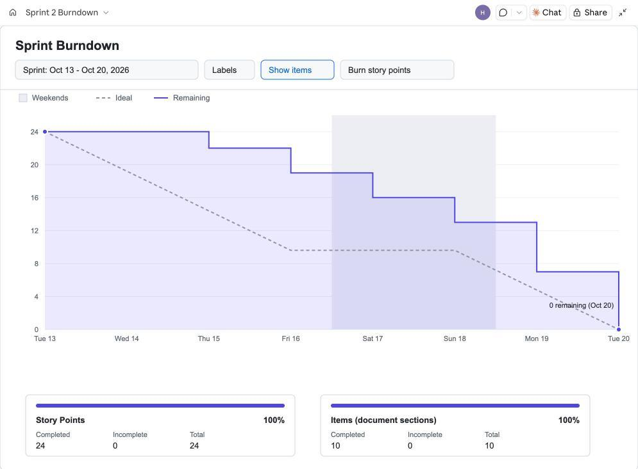
Figure BD-01 - Sprint 2 Burndown, Oct 13 - Oct 20, 2026 (10 document deliverables from the Meeting 2 task table, 24 story points, all completed by Oct 20; no issue tracker was used, so the day-by-day values are reconstructed from the team’s meeting notes and are approximate)

